Hyperbolic metamaterials: basic properties and formalism to describe the dispersion

F. Vaianella and B. Maes

Micro- and Nanophotonic Materials Group, Faculty of Science, University of Mons, 20, place du Parc, B-7000 Mons, Belgium

Hyperbolic metamaterials are intensively studied because of their interesting properties. A review of hyperbolic properties and a simple theoretical comprehension of their dispersion via coupling of elementary excitations of a simple multilayer metal-dielectric structure will be presented. The same approach for more complex structures will also be studied.

# Metal-dielectric multilayer structure

A simple subwavelength periodic metal-dielectric structure (Figure 1a) can exhibit hyperbolic properties [1].

(b)

(a)

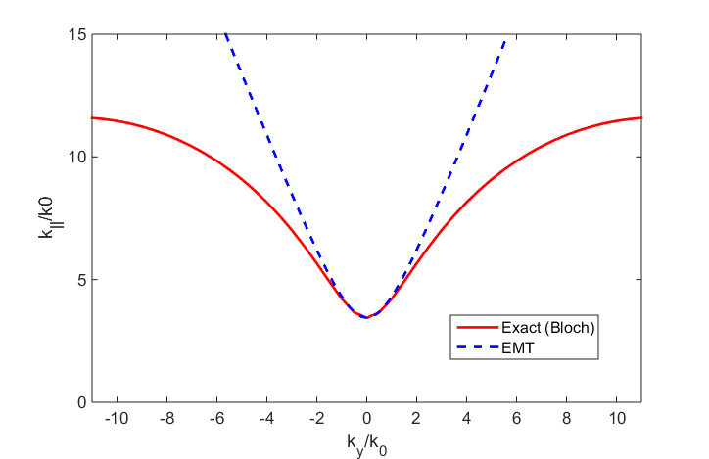



Figure 1: (a) Periodic metal-dielectric multilayer structure with silver as metal and TiO2 as dielectric. (b) Isofrequency contour at a wavelength of 700 nm for multilayer structure with a metal thickness of 10 nm and a dielectric thickness of 20 nm. Red line is the exact calculation and blue line is the effective medium theory.

Such type of structure is strongly anisotropic and has a uniaxial form of the dielectric tensor $\overset{⃡}{ε} \left(\vec{r}\right)$ with only two independent directions:

$$\overset{⃡}{ε} \left(\vec{r}\right)= \left(\begin{matrix}ε_{xx} & 0 & 0 \\ 0 & ε_{yy} & 0 \\ 0 & 0 & ε_{zz}\end{matrix}\right)$$

with $ε_{xx}= ε_{zz}=ε_{∥}$ and $ε_{yy}=ε_{⊥}$. Effective medium theory for this type of structure gives an isofrequency surface for propagating TM-polarized waves as:

$\frac{k_{x}^{2}+k_{z}^{2}}{ε_{⊥}}+ \frac{k_{y}^{2}}{ε_{∥}}= \frac{ω^{2}}{c^{2}}$

Under some conditions, the permittivity of the structure can be such that $ε_{∥} . ε_{⊥}<0$ and the iso-frequency surface is an open hyperboloid (Figure 1b). This hyperbolic isofrequency surface leads to interesting properties such as an extreme effective index and an infinite density of states [2]. However, for large wavevectors (ky near the Brillouin zone edge or large frequencies) and because of nonlocality effects, effective medium theory cannot be used anymore [3]. Moreover, these nonlocality effects lead to a second branch of propagating waves that is not predicted by the effective medium theory.

# Dispersion of a metal-dielectric multilayer structure

The dispersion of a metal-dielectric multilayer structure can be analyzed as a competition between elementary excitations that are plasmonic gap modes (field dominant in dielectric layer in between metal) and plasmonic slab modes (field in metal layer in between dielectrics) [4]. This type of approach is very interesting because it enables to identify the intersection between the two plasmonic branches and the symmetry of the propagating modes. This approach allows also to engineer the dispersion in a desired manner.

# Rectangular nanorods array

A major problem of the multilayer structure is that it contains a lot of metal that leads to important losses and the high-k waves propagate in the transverse plane. We examine the case where we put holes in the metal and fill them with dielectric. The structure we examine is thus a periodic array of rectangular nanorods [5] (Figure 2a).

TiO2

Ag



Figure 2: (a) Rectangular nanorods array with nanorods of silver in a TiO2 medium. (b) Isofrequency contour in the x-z plane for a nanorods array with rod of width = 20 nm and height = 10 nm with a periodicity of 30 nm

(b)

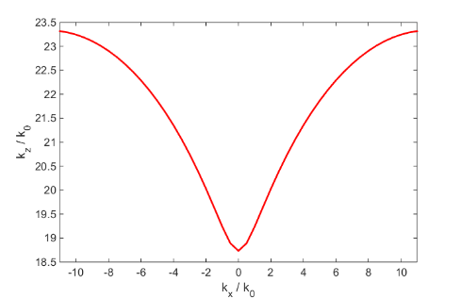

(a)

This kind of structure still exhibits hyperbolic properties (Figure 2b) even if the metal fill fraction is much lower than in the multilayer case and the guided waves propagates along the z-direction (along the nanorods). The same approach than in the multilayer case can be used to analyze the dispersion, but the elementary excitations are in this case different.

# References

1. H. N. S. Krishnamoorthy, Z. Jacob, E. Narimanov, I. Kretzschmar and V. M. Menon, “Topological Transitions in Metamaterials”, Science, vol. 336, pp. 205-209, 2012.
2. T. Galfsky, H. N. S. Krishnamoorthy, W. Newman, E. E. Narimanov, Z. Jacob and V. M. Menon, “Active hyperbolic metamaterials: enhanced spontaneous emission and light extraction”, Optica,

vol. 2, pp. 62-65, 2015

1. A. A. Orlov, P. M. Voroshilov, Pavel A. Belov,1,2 and Yuri S. Kivshar, “Engineered optical nonlocality in nanostructured metamaterials”, Physical Review B, vol. 84, pp. 045424, 2011.
2. G. Rosenblatt and M. Orenstein, “Competing coupled gaps and slabs for plasmonic metamaterial analysis”, Optics Express, vol.19, pp. 20372-20388, 2011.
3. P. Berini, “Plasmon-polariton waves guided by thin lossy metal films of finite width: Bound modes of symmetric structures”, Physical Review B, vol. 61, pp. 10484-10503, 2000.