Development of bimodal contrast agents for paraCEST and ¹⁹F MRI
Pierre Ernotte
Pierre Ernotte^{[a]} ,Céline Henoumont^{[a]} Sophie Laurent^{[a], [b]}
[a] General, Organic and Biomedical Chemistry, NMR and Molecular Imaging laboratory, University of Mons, 7000 Mons (Belgium)
[b] Center for Microscopy and Molecular Imaging (CMMI), 6041 Charleroi-Gosselies (Belgium)
Introduction :
Magnetic Resonance Imaging (MRI) is a widely used imaging technique and it often requires the use of contrast agents to increase it’s sensitivity. Several classes of contrast agents are under development, as paraCEST and ¹⁹F MRI contrast agents. In this work, bimodal agents active in both paraCEST and fluorine MRI are synthesized.
The paraCEST complexes synthesized are derived by adding fluorine atoms. The interaction between the fluorine atoms and the paramagnetic ions can generate an increase in ¹⁹F MRI sensitivity.
Methods:
DOTAM derivatives where chosen as paraCEST ligands as they are well known to reduce the innersphere water exchange rate. Bis-trifluoro benzylamine was then grafted to the chelate using a lysin derivative. The organic ligands were completely synthesized using cyclen as starting material. The ligand were finally complexed with thulium, ytterbium and europium.
To characterize the CEST efficiency, Z-Spectra were recorded using a 679Hz saturation pulse, at 37°C and 600MHz. To evaluate the efficiency in ¹⁹F MRI, ¹⁹F relaxation times measurements were performed at 11,75 Tesla.
Results/Discussion
The ligands were synthesized using organic chemistry and were characterized by NMR and ESI-MS (figure 1).
The bimodal ligand shows a good water solubility, it was then complexed with several lanthanide ions: Thulium, Europium and Dysprosium. The europium complex shows an expected great CEST signal at around 50ppm, which is due to a coordinated innersphere water molecule. Thulium and Ytterbium demonstrate two CEST signals, probably due to the two types of amides present on the chelate.
¹⁹F relaxation times measures were then performed before and after complexation to evidence the influence of the paramagnetic ion on those relaxation times. It was observed that europium has a small impact while the ytterbium, and more specifically thulium have a greater influence.
Conclusion:
The complexes were successfully synthesized and characterized. The europium bimodal complex exhibits a great CEST effect but has relatively long ¹⁹F relaxation times. The thulium and the ytterbium complex both have a lower CEST effect, but the reduce the ¹⁹F relaxation times more efficiently. To increase their sensitivity, the grafting on a nanoplatform is being studied.
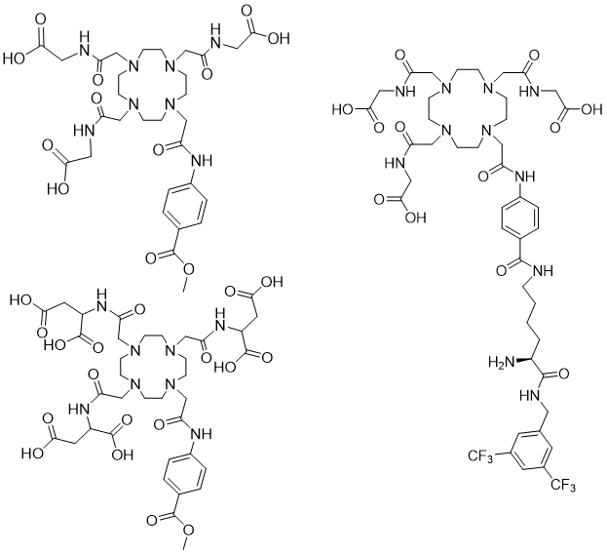
Figure 1: Structures of the different ligands synthetized

