Article
Exploring Urbanization Challenges on Land-use from Smart City Perspectives: The Case of Bahir Dar City in Ethiopia
Abebe Dress Beza¹, Christos S. Ioakimidis ^{2,}* and Sesil Koutra ¹,^{3,}*
Citation: Lastname, F.; Lastname, F.; Lastname, F. Title. Urban Sci. 2021, 5, x. https://doi.org/10.3390/xxxxx
Academic Editor: Firstname Lastname
Received: date
Accepted: date
Published: date
Publisher’s Note: MDPI stays neutral with regard to jurisdictional claims in published maps and institutional affiliations.
Copyright: © 2021 by the authors. Submitted for possible open access publication under the terms and conditions of the Creative Commons Attribution (CC BY) license (https://creativecommons.org/licenses/by/4.0/).
¹ Faculty of Engineering, University of Mons, Mons, Belgium; abebedress.beza@student.umons.ac.be (ADB);
² Center for Research and Technology, Hellas/Hellenic Institute of Transport, CERTH/HIT, 6th Km
Charilaou Thermi, Macedonia, Hellas, Thessaloniki, Greece; cioakim@certh.gr (CSI);
³ Faculty of Architecture and Urban Planning, University of Mons, Mons, Belgium; sesil.koutra@umons.ac.be; (SK)
* Correspondence: cioakim@certh.gr
Abstract: Presently, smart city concepts have gained immense interest worldwide dealing with issues of planning and city design. Research interest is rising in growing developing cities of the world with little evidence of the rapid urbanization phenomenon and the significance of ‘smart’ contributions. In this work, we explore the phenomenon in, Ethiopia’s Bahir Dar studying the challenges and risks but also emphasizing on the land-use in a ‘smart’ management. The main aim of the current study is to explore the process of urbanization and its effects on the rapidly growing city of Bahir Dar and to outline the main challenges related to land-use management. This study reviews the literature on challenges to capture the historical evolution of Bahir Dar and its status to make inferences on the implementation of smart land-use solutions considering the local situation. The findings pointed out that linked to rapid expansion, unsatisfactory land-use administration combined with slum areas and informal settlements in the city have been drastically increasing each year. From smart land-use management aspects, three interconnected elements have been outlined: a) up-grading slum areas in the inner city, b) the necessity of a smart land information system, and c) citizen participation. It is also revealed that the rise in population density and poor quality of life in the slum area accompanied by the absence of an integrated land information system result in an informal settlement in the outskirt of the city. Likewise, the land-use policies, regulations, directives, and institutional arrangements lack transparency and consistency over time and space, which shows the necessity of citizen participation in the decision process.
Keywords: Bahir Dar city; Land-use; Smart city; Urbanization challenges

1. Introduction

1.1 The Challenge of Urbanization and the Case of Africa
‘Urbanization’ is the phenomenon whereby populations are congregated and moved in urban areas ([1]-[2]) and it is a significant phenomenon affecting modern cities globally [3]. The first peak of the phenomenon was observed in 2007 in urban areas [4], while the projections by 2050 expect an increase in the urban population by 72% (from 3.6 in 2011 to 6.3 billion in 2050) [5]. In this regard, Davis [6] explains the rapid urbanization in Africa is at a faster rate worldwide (from 3 to 5% annual growth) within an overall continuous projection to double its population from 300 million (in 2000) to 750 million (in 2030). This rate is predicted to be the highest in any other continent (700%) over the period 2000-2030 [7], while in 2030 it is estimated that over 60% of inhabitants will live in urban areas from which the highest growth will be in Africa and Asia [8]. Rapid and uncontrolled urbanization will result in a substantial strain on the livability of cities. Implementation of smart city concepts in urban development in developing countries plays a noteworthy role to enhance living standards.

1.1.1 The Case of Ethiopia and the Bahir Dar city
Throughout its history, Ethiopia has remained principally a land of villages and isolated homesteads because of the royal camp, a reason explained and provided in Pankhurst’s studies [9]. According to recent studies, Ethiopia is becoming one of the fastest-developing populations worldwide with rising expectations to triple between 2010 and 2040 [5]. Today, Ethiopia is one of the mostly developing nations as rated in world’s documentation; among the 80 countries, it is at the 15th highest rate of urban growth for the period 2010-2040, while preliminary studies observe that this increasing rate is found on some of its largest cities, including Bahir Dar [10].
According to studies provided by Ethiopia’s CSA [11], Ethiopia’s urban population has more than doubled in the past 20 years from 7.3 million (1994) to an estimation of approximately 17 million for 2014 with uncontrolled and unstructured sprawl due to the urban migration [12]. The same report concludes that Ethiopia has the second largest population in Africa (94.4 million in 2017), which is translated into a level of urbanization of 20.3% and a yearly growth rate of 2.45% causing significant urban challenges, for instance in respect to its landscape and land-use management.
Complementary to these projections, the same report concludes that:
- Before 2018, natural increase is projected to be the major contributor to urban population development, contributing between 266,000 and 429,000 citizens, meaning to reach approximately 40% of total annual urban population growth;
- Formal expansion of existing urban centers will consistently account for 2 to 4% of the total growth annually, from 22,000 in 2012 to 67,000 in 2032.

1.2 Research Questions and Organization of the Work
The main aim of the current study is to explore urbanization and its impacts on Bahir Dar city from smart city perspectives and to outline the main challenges related to land-use management. This study reviews the literature on urban challenges to capture the historical evolution of the city and its status to make inferences on the implementation of smart land-use solutions considering the local situation as shown in Figure 1. This paper answers two main research questions.
These are:
- What are the connections between urbanization and its challenges on land-use management?
- How to apply smart city solutions to alleviate urban challenges in Bahir Dar?
The remaining of the paper is organized as follows. Section 2 describes the historical evolution of Bahir Dar into two timelines, early settlement, and the modern era. Section 3 is dedicated to exploring the land-use management in the city while Section 4 highlights the framework for smart land-use management. To this end, conclusions are drawn in Section 5 summarizing the main findings of the work.
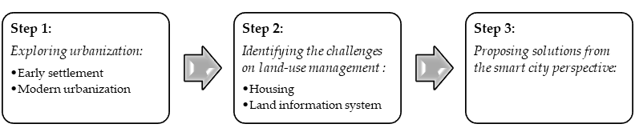
Figure 1. Research procedures

2. Bahir Dar city and Urbanization Challenges
Bahir Dar (meaning “seashore” in Amharic) is the capital of the Amhara region in Ethiopia regarding Tana Forum (2015) [18], Bahir Dar got its name during Emperor Yikuno Amlak. The early history of Bahir City is not well documented in the existing literature with a size and population roughly estimated before 20th century. Broadly, the city is listed as one of the Christian towns with a permanent population of at least 2.000 inhabitants in 1810-1850, while the evidence of its evolution accounts for three nuclei; the first phase is that of traditional land practice with everyday urbanization, leading to the establishment of an early dense settlement of the city’s today vision. Contrary to other Ethiopian cities, Bahir Dar began its planning (as an organized process) much later as it was firstly appeared as a fishing village and trading agglomeration. Thus, there is little evidence on its settlement history from its founding period. The second phase of its urbanization procedure is marked by the five-year occupation by the Italians with the colonial status (in 1936) and imposed their urban administration and land regimes. This impact, nonetheless, was relatively minor to the subsequent urban layout of the city and the occupiers did not reshape the existing architectural and building historical existing patterns. The third phase of its urbanization is inaugurated with the reinstitution of Haile Selassie as Emperor (1941), in which the city introduced its master plan and set its urban development under serious negotiations. From this moment, the city planning of Bahir Dar has been of centralistic interest on the political debates. Its expansion is basically triggered by the plans for industrial evolution and use of hydropower leading the phase of urban growth of the city. The phase of its master planning is the fourth period of the socialist doctrine, in which the urban development was experienced [12].
In regards to its physical characteristics, Bahir Dar city’s absolute geographical location is at about 11°37’ north latitude and 37°25’ east longitude. As of this geographical location, it has a road network of 550 km via Bure and 460 km via Motta from Addis Ababa, the capital of Ethiopia (Figure 2) and it is located on the south of the largest lake in Ethiopia, Lake Tana where the Blue Nile (Abay) river starts snaking through the city.
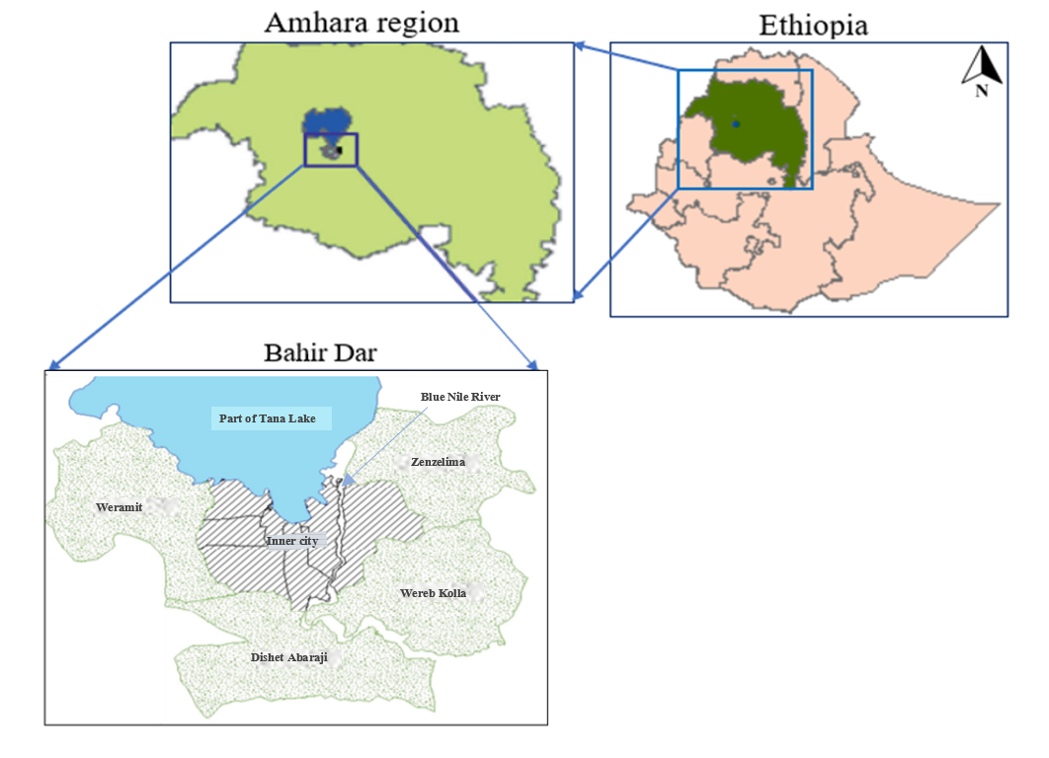
Figure 2. Geographical location of Bahir Dar city

The city has an estimated total area of 42.000ha, of which 2.258ha are covered with water accounting 17.2% from its total land, while 3.842ha is constructed. For administrative purposes, it was classified into 17 urban kebeles (local administration), while the 2006 restructuring decreased urban kebeles to 9 and also incorporated one peri-urban kebele, Zenzelma, and 3 rural kebeles, namely Woreb Kolatsiyon, Woramit, and Sebatamit [13]. Bahir Dar city presents two main administrative subdivisions: urban and rural. The urban part consists of 9 sub-cities while the rural part has 4 peri-urban agrarian kebeles (considered as the lowest administrative unit in Ethiopia); the 4 prompt peri-urban areas and the inner city which has an estimated area of 16 ha [16] (Figure 2, [18]).
The present structure of the city has four peri-urban kebeles (Weramit, Dishet Abaraji, Wereb Kolla, and Zenzelima) as displayed in Figure 3 [14]. Bahir Dar city is the third biggest city in Ethiopia with 329,318 inhabitants [15] and represents a very interesting potential for future urban development due to its urban nodes (proximity), energy and research infrastructures, its rapid economic growth, the high fertility of its hinterland as well as its cultural heritage and landscape. As many African cities, Bahir Dar has been encountering an impressive and continuous population growth associated with the phenomenon of urbanization, which is among the main impetuses for its district proliferation [16]. Daniel [17], in his works, estimates that about 30% of the urban population lives in spontaneous settlements excluding those found in slums of the inner city. This growth moves to diverse challenges related to many environmental-interrelated ones, such as the scarcity of potable water, electricity, drainage system, and inaccessible city amenities.
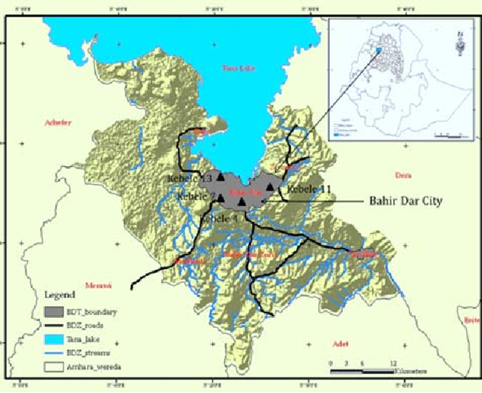
Figure 3. The Bahir Dar city including four peri-urban kebeles
Urbanization and the corresponding urban planning in the city of Bahir Dar have been explained in two timelines. The first one is the early settlement (before 2000) while the second part illustrates its urban element in the 21st century, the modern era. Haregeweyn [19] in his study explains the rapid horizontal area expansion, which was increased from 279 ha (1957) to 4,830 ha (2009). In other words, the city has displayed an expansion of more than 17 times for the period of 1957-2009 with a mean growth of more than 30% (meaning 88ha per annum).
As indicated by the Population and Housing Census data (retrieved by the Ethiopian CSA [20]), the aggregate population of the city was 11,900 in 1965, 54,766 in 1984, 96,140 in 1994, 180,094 in 2007, and 313,997 in 2017 (Figure 4).
Figure 4. Population growth in Bahir Dar from 1965 to 2017

2.1 Early Settlement
Bahir Dar city progressed from monastery administration known as ‘Gadam’ and marketplace to one of the fastest-growing cities in Ethiopia. The present name of the city is derived from the Ethiopian Orthodox Christian Monastery called Bahir Dar Gyorgis. In 2012, a study by Seyoum [21] emphasized that the first written mention of Bahir Dar city was in 1842 by a Belgian consul, Blondeel, who visited the settlement and mentioned Bahir Dar as a small sacred village. Seyoum also highlighted, since then, other European travelers have visited Bahir Dar and some of them considered it as a village, while others state it is a ‘marketplace’. Furthermore, he mentioned that it was at the beginning of the 20th century that Bahir Dar had received tremendous attention both from international travelers and local people.
In the 1930s, Bahir Dar advanced to a contemporary urban hub. In particular, starting from 1936, the city viewed new improvements in respect to the water transportation on the lake of Tana, for instance. In 1948 the Ethiopian government launched officially the planning schemes (master planning) for Bahir Dar city, by which the street network was improved by upgrading the old ones. The first full-fledged master plan was prepared by a team of German planning experts in 1965 [16].
Until 1936, the former settlement structure of Bahir Dar is called the ‘Balabat’ community, which is comprised of 16 heads of ‘Balabat’ and some other Christian families, who worked on church land. Agriculture followed by commercial activities was the most important means of living. It was also revealed that the society was segregated based on religion and working classes as Kahenat (Clergy), Balabat (the Christians), Tanners, Muslims, and Waytos [21]. As depicted in Figure 5 [21], the main settlement was around the port and the Ethiopian Orthodox Church of Saint George, which plays the main role in the development of the city.
From 1936 to 1941, Bahir Dar became the administrative center of the whole region of Gojam. In this period, the older buildings were removed, and the land was then allocated for different purposes, such as offices, army barracks, airstrip, and port services on the lakeshore and new residential and commercial zone. That was the period when a remarkable change has happened in the urbanization history of Bahir Dar. After 1941, the land administration practice was transferred into the new administration system without significant changes, and the status of the municipality was raised in 1945 which had around 4,000 inhabitants [12]. In the 1990s, Bahir Dar experienced significant growth and expansions. Becoming the capital of the Amhara region, Bahir Dar is not only an administration center, but also a core of commerce, transport, industry, communication, education, health, and tourism [21].
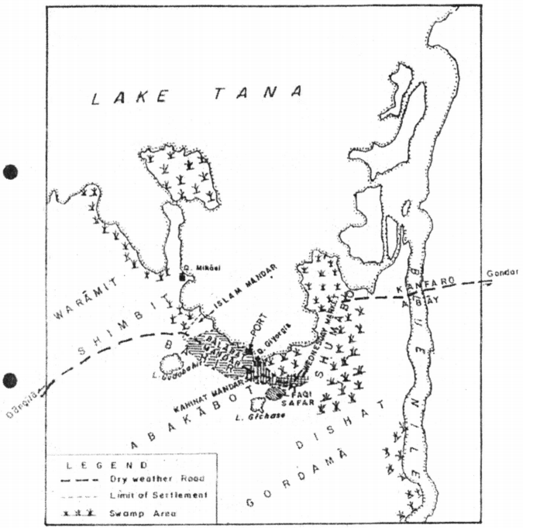
Figure 5. The general settlement pattern of Bahir Dar before 1935

2.2 Bahir Dar in the 21st Century
In the modern era, Bahir Dar is one of the rapidly growing cities in Ethiopia. According to the CSA, in 1984, the population of the city was 54,800. After ten years, in 1994, the population raised to 96,140 and in 2007 to 221,991 [22]. In 2003, the city was dealing with growth rates of 4.8% per year with expectations of doubling between 2012-2014. Currently, it is experiencing a rapid population growth approximately by 6.6% annually. As projected by CSA, in 2019, the population size has increased to 397,923 [23]. Bahir Dar has been growing mainly horizontally which causes a significant land cover change from agricultural land use to the built-up environment.
The mobile population (internal migrants) is a crucial part of Bahir Dar’s development dynamic. The main reasons to migrate into Bahir Dar are for studying, marriage, pre-arranged work, and housing. Presently, the inflow of daily workers to the city is firmly endorsed by labor opportunities in the production and construction industry. Unlike the students arriving to attend their study at Bahir Dar University, however, who are fully accommodated in the city. The young migrants coming to the city to engage in wage labor question the rural-urban dichotomy by forming a category of urban residents that does not fully suit the implications of urban development.
The main activities and income generation in Bahir Dar include trading, education, services and administrations, production and processing, revenue, third-part support, forging, mining, and gathering. Figure 6 shows the most important subsistence activities and income generation in the city [12].
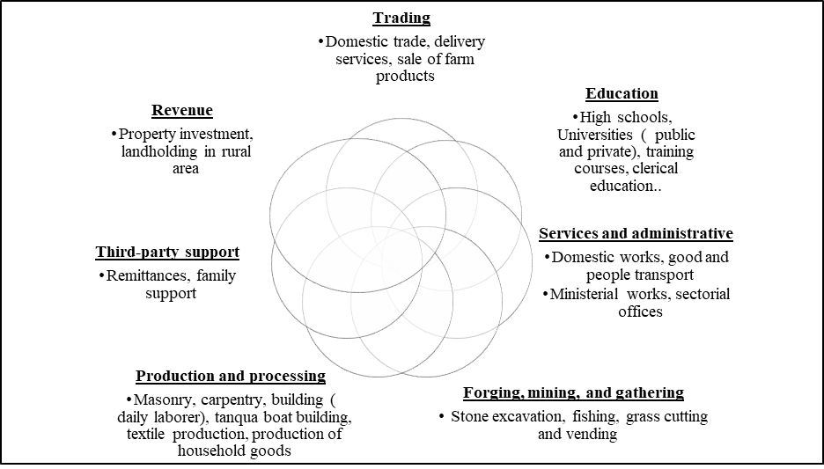
Figure 6. Subsistence activities and income generation in Bahir Dar
According to a recent study [24], the city of Bahir Dar has a total road length of 667.25 km with a density is 10.7 km/km². Based on its hierarchical structure, the city’s road network can be classified into primary (16%), secondary (2%), and collector and local roads (82%). The higher percentage of the road surface is red ash (34%) and earthen road (29%). However, a significant share of the road network has asphalt (17%) and cobblestone (16%) surfaces. The most frequently used mode of urban transport is three-wheeled vehicles which have a share of 49.9%. Walking, 12-seater taxis and bicycles have also significant contributions which are responsible for 14.1, 20.2%, and 10.4% of the trips respectively. Furthermore, other modes including motorcycle, bus and private cars cover 5.4% of the trips.
The rapid urbanization in Bahir Dar imposes a substantial impact on land-use management. On one hand, urbanization raises land-use and land cover change from agricultural to built-up environment which affects the housing demand both in the inner city and peri-urban areas.

3. Land-use Management in Bahir Dar
Broadly, in Ethiopia, the Constitution stipulates the distribution of its land owned by its citizens reducing the administration’s role in the land management, which acts as the sole supplier of land. Simultaneously, the current land management system is not delivering enough land for public uses, including roads and streets [25].
Apart from the abovementioned statements, understanding the history of urbanization in Bahir Dar city, the Ethiopian urban land policies and their applications affect the informal housing development. Similarly, the growing housing requirements due to the increasing population deficit and the low physical quality (lack of basic amenities on an important number of dwellings) driven to high relocation of migrants (basically from rural to urban areas) led to problems of affordability and housing accessibility.

3.1 Built-up Property Formation
Generally, in Ethiopia and particularly in Bahir Dar, both the formal and informal actors play the main role in the transformation of agricultural peri-urban areas into built-up environments. As shown in Figure 7, in the process of urban land property formation, both formal and informal systems have been practicing in parallel one affecting the other. The formal one follows the legal procedures that are covered by the laws while the informal system corresponds for non-legitimate and unauthorized forms of land transactions and construction. The formal urban expansion is dependent on compulsory expropriation and reallocation of land which comprises three main steps [26]:
- The pre-urban area should be included in the master plan of the city;
- An expropriation decision must be made;
- The land should be reallocated to different public and private users through a lease contract based on annual ground rent for a specified horizon.
When the urban boundary theories the pre-urban territory, the landholders are assumed to be expropriated by default. Besides, the amount of compensation varies based on the planned land use: for federal institutions or regional institutions. If the land is used by the federal institutions the compensation will be higher than the amount that might be paid by the regional government.
Informal development and settlements are the second types of land acquisition in the urban expansion of Bahir Dar. The following points are the main driving factors for the expansion of informal settlement in the outskirt of Bahir Dar (Figure 7) [26]:
- Insufficient expropriation money: the pre-urban landholders expect that their land will be taken by the urban administration, and they think that the amount of money given as expropriation is not sufficient;
- Insecurity land tenure: due to a rapid rate of urban expansion the local landholders have a prevailing feeling of insecurity about their land. Therefore, they want to make as much profit as they can by selling their land to other individuals informally and illegally;
- The rise of house rent in the inner city: the expensiveness of house rental for low-income people and the availability of informally subdivided parcels at a cheap price have been a driving factor for moving to the outskirt. About 92% of informally settled people in the peri-urban areas moved from the inner city.

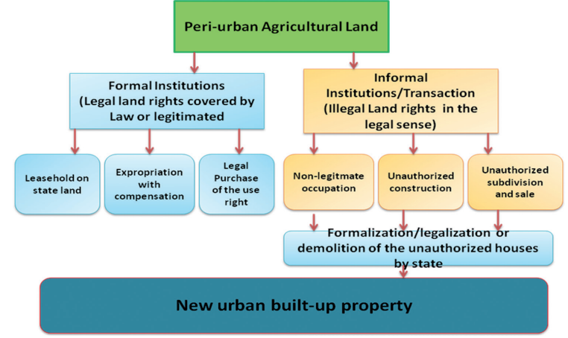
Figure 7. Formal and informal urban land property formation

3.2 Land-use Changes
Tacoli [27] brings the problems and consequences of rapid urbanization to find persistent economic development; even though urbanization enhances globally the fiscal advancement in poor nations, simultaneously it leads to undesirable burdens. The problem highlighted in many studies (i.e. [28]) of the absence of essential facilities (clean water, sanitation and electricity) is of the main anxieties to users. At the same time, one of the most important challenges to this phenomenon is directly associated with the rising housing demand, which is anticipated to accommodate a growing population in its urban centers [16].
Based on data from Bahir Dar city administration (2015) [29], different formal and informal stakeholders contributed to the registration of a housing stock of 69,943 dwellings. The private or owner-occupier housing is the leading provider as reflected in the number (31,692) accounting for 45.3% of the total (Table 1). Informal housing construction contributed the second largest number of housing units (23%), while private rental contributed 22.9%. Kebele houses, real estate developers and public rental contributed the lowest percentages of 5.6, 2.9 and 0.2, respectively.
Table 1. Housing supply and demand in Bahir Dar in 2015
Housing types | Housing supply |  | Housing demand |  | Proportion of supply to demand (%)
 | Number | % | Number | %
Formal housing
Condominium | 3,700 | 5.02 | 45,521 | 29.36 | 26.98
Public rental | 119 | 0.16 | 12,561 | 8.10 | 8.03
Kebele houses | 3,883 | 5.27 | 27,657 | 17.84 | 15.33
Real estate | 2,035 | 2.76 | 17,988 | 11.60 | 10.29
Private/owner occupier | 31,692 | 43.03 | 51,309 | 33.09 | 12.65
Sub-total | 41,429 | 56.26 | 155,036 | 100 | -
Informal/partially informal
Private rental | 15,981 | 21.70 | 0 | 0 | -
Informal housing | 16,233 | 22.04 | 0 | 0 | -
Sub-total | 32,214 | 43.74 | 0 | 0 | -
Total | 73,643 | 100 | 155,036 | 100 | -
In 2015, a report from the World Bank and Ethiopian Urban Development, Housing and Construction [30] indicated that land-use modification from an agricultural area to a built-up area is surging up drastically since 2012 and it will keep increasing in the coming decades at an estimated yearly rate of 3.8 % -5.4%. The report also highlighted Bahir Dar is one of the cities where higher urbanization is occurring, and the land-use pattern is complex and quite challenging for predictions mentioning that 25% of the land in the prime location is underused.
In 2020, Fitawok et al. [31] investigated the land-use change of Bahir Dar city using an integrated cellular automata-Markov chain model. In order to analyze and predict the land-use change, they used Landsat images dated 1991, 2002, 2011, and 2018 and their findings pointed out that the built-up area for the respective study years was 1246, 2708, 3202, and 4343 in hectares. They also predicted that land-use change from agricultural land to the built-up areas will be persistent in the north-eastern, south-western, and southern areas of the rambling city. Another study by Kindu et al. [32] assessed the land-use change over 30 years (1985 – 2015) and demonstrated that the built-up area has expanded by 250.5% over the study period.
In 1987, many places of the city were covered by croplands, while settlements, open spaces, paved surfaces, industrialized and other areas were concentrated in the city center and an important part of its land was covered with forest. A thought-provoking study conducted by Wubie et al. [33] investigated the dynamics of spatial expansion and land-use patterns in Bahir Dar for three decades (1993 - 2020). The results from their study revealed the expansion rate of the city is 5.01%, 7.75%, and 7.74% from 1993 to 2001, 2001 to 2011, and 2011 to 2020, respectively with an annual average expansion rate of 6.73%. Figure 8 depicts the land use and land cover of the city in 2020 which shows the city is expanding horizontally in almost all possible directions.

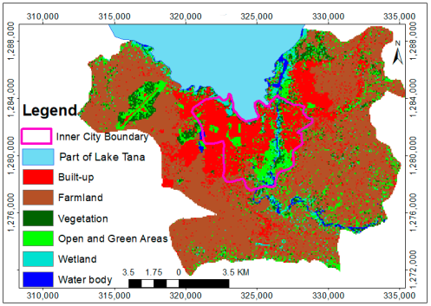
Figure 8. Land cover map of Bahir Dar city and its peri-urban areas in 2020

4. Formulating the Framework of Smart Land-use Management
In Ethiopian cities including Bahir Dar, the smart city concept has not been received remarkable interest from policymakers, researchers, and practitioners. However, there are attention-grabbing initiatives countrywide. The “Digital Ethiopia 2025” is one of the promising initiatives for further adaptation and implementation of smart city concepts. This initiative targeted four paths including unleashing value from agriculture, global value chain in manufacturing, IT-enabled service sector, and tourism competitiveness [34].
Among the urbanization-imposed challenges of Bahir Dar city, housing shortage, slum areas, informal settlements, and lack of citizen participation in the decision process are the most triggering concerning smart city development. In slum areas and informal settlements, the houses are self-constructed shelters that do not fulfil the Ethiopian building codes of standards. The houses are usually made of fragile local materials including mud, wood, plastic fabrics, and bamboo. Besides, the slum areas and informal settlements lack adequate infrastructures such as electricity from the grid, sewerage system, and potable water [35].
From the works of literature, hindering components of a land-use have been identified which are urban slum in the inner city, citizen participation, land information systems due to the following reasons. On one hand, the low quality of life in the inner city has been encouraging informal settlement in the outskirt of the city. Secondly, an unintegrated land-use information system accompanied by inadequate citizen participation has been considered as one of the main reasons for the rising of informal settlement and land-related disputes in the peri-urban area of the city [26].
Appelhans [12] classifies the history of the urban development of Bahir Dar city in four main schemes: the inner city, the informalized village, the workers’ settlements and the Bahir Dar University’s main campus (Figure 9).
Figure 9. Four sub-cases in the Bahir Dar city by: [12]

4.1 Upgrading Slum Areas in the Inner City
The inner city is the oldest settlement of the Bahir Dar considered as the first urban administration under the Italian occupation chosen as the core of the city with overall bad living conditions and lack of basic infrastructure and population services. In the current urban development trend of Bahir Dar, inhabitants, who live in the slum areas, are evicted from the center of the city to the outskirts and the inner city faces urban pressures for redevelopment and rehabilitation. However, this trend is not a socially sustainable way of urban development as it disrupts the social fabric in the community. First, it results in a demographic change of the city by reallocation of the poor and replacing them with the rich one which is against the livability and smartness concept of the present urban development since it highly disturbs the social cohesion that has been developed in the last decades among the inhabitants. Secondly, it encourages informal settlement in the outskirt of the city as there is no sufficient infrastructure in the outskirt of the city. Slum areas are usually found in the inner city such as ’Sefene Selam’ and ‘Gish Abay’ sub-cities. Besides, it is important to note that there are slums in the outskirts of the city, where informal settlement exists [35]. Above and beyond, according to another study conducted in 2011 by Prime Consultant for cadastral survey work, 30% of the city’s houses were recognized as informal settlements comprising of slums [36].
Currently, there are best practices worldwide that can be properly investigated and adopted in Bahir Dar city. One of the soft solutions is that developing policies and strategies that encourage the building of shared housing especially for students, temporary residents, and low-income inhabitants. More importantly, students attending their training at Bahir Dar University are increasing from time to time. The university has approximately 40,000 students every year. However, all students have not been receiving dormitory accommodation from the university. Hence, they live in the city center that rises house rental demand in the city center that directly influences inhabitants to move towards the outskirts of the city [37]. Given that, encouraging the university and other higher education institutes in the city to develop a shared accommodation service for the students is noteworthy to reduce slum area in the city center. Above and beyond, promoting private organizations in collaboration with financial institutions to participate in the housing sectors will facilitate the process of shared accommodation services.
The other solution can be a relocation of the intercity bus station. The intercity bus station is in the inner city, and it has been the main cause of congestion and has negative impacts on the slum area in the center. The presence of the intercity bus station increases not only the bus traffic but also the taxi and Bajaj (three-wheeled vehicle) in the center. Furthermore, the road network in the city center is not sufficiently wide to accommodate different traffic including large buses, cyclists, and pedestrians. More importantly, this bus station has been used as a transport hub to connect Bahir Dar to other Ethiopian cities in the north and northeast parts of the country including Gondar, Woldia, and Debre Tabor. Hence, relocating this bus station to the north-eastern part of the city (which is usually called ‘abay mado’) will result in a reduction of vehicular traffic in the slum area and provide a better public space that improves the livability in the inner city.
As far as the workers’ settlements concern, the area is divided into a residential compound and is considered as a main source of labor and limited facilities. The area is completed by the so-called ‘informalized village’ with rural attributes and an increasing rate of its densification. Finally, the University campuses distributed across several institutions and building infrastructure for studying requirements.

4.2 Smart Land Information System and Efficient Land Administration Systems
An integrated land information system is one of the main aspects of the smart city concept, which has a noteworthy benefit in urban development. Smartness in the context of land use management can be defined as “the combination of both smart citizens, who are able to use information and communication technologies to advocate and pursue their interests, and on smart information-processing, i.e., facilities which can fuse data from all types of sources and platforms” [38]. A smart land information system can accelerate efforts on the road to sustainable urban development for developing nations and this is specifically correct for Ethiopia in general and Bahir Dar city, in particular where there are weaknesses in land administration institutions [39].
There is a variation of information on land use in urban and peri-urban areas. Besides, the built-up property formation rules and regulations are different in urban and rural areas due to inconsistencies in the land administration institutes. Recently in 2021, a study by Wubie et al. [40] underlined that data inaccessibility, inconsistency of the tenure system, lack of citizen participation in the urban expansion are the most notified problems in the current urban development and indicated the current land information system is also fragmented, into urban and rural institutions and it has been the main challenge in the management of settlements in peri-urban areas and it has been a source of dispute in the city. Developing a land information system is a foundation for property valuation, land-use development, land transaction, and resolving land-related disputes in the peri-urban areas of Bahir Dar city. As outlined in the study Chekole et al. [39] the land information system should focus on the following aspects:
- Precise inventories of land plots;
- Exact picture of the authorized situation of landholding;
- Consistent database for the administration of public lands;
- Base for valuation and taxation, and
- Evidence of ownership for legal cases.
At the same time, to address the crucial issues of informal housing in Bahir Dar city especially about the land administration the following solutions are recommended:
- Development of a legal and overall policy framework supporting the security of tenure;
- Recognition of informal land rights for the existing settlements;
- Development of transparent procedures for officially recognized rights and regime’s ability to implement systems within these mechanisms and
- Enhancement of the accessible land administration systems by all the involved citizens. ciy

4.3 Citizen Participation
In order to attain their optimal smart city objective, cities should allow active citizen participation in the design process [41]. However, studies (i.e. [12], [26], [40]) showed that in land-use decisions, citizens have not effectively participated in Bahir Dar.
As pointed out in the study by Alemie et al. [42] the existing land information system in Bahir Dar was not based on a societal needs’ evaluation, rather it was a recommendation of a foreign consultant that drove the changes. They also pointed out that when the land administration policy was released, there was significant societal resistance since no effective participatory methodology was applied through the policy-making processes. Provided that, the residents living not only in the city center but also in the peri-urban area should have active participation in the development of modernized land information system. A study by Chekole et al. [39] highlighted that there is a gap between decision-makers within the field of the land administration theme on an understanding of the existing situation. Hence, responsible land-use authorities are required to consider criteria such as the design of policy and strategy via citizen participation, quality of governance, delivery of resource and partnership, and the process, to enhance the implementation of urban land information systems.
In 2020, Wubie et al. [40] conducted a land-use intervention for socio-spatial evaluation of Bahir Dar city in a sample of 384 households showed 57% of the respondents believe, besides lack of clarity in the communities, the land-use policy has no clear integration and proper implementation among different institutions. The same study based on a focus group discussion indicated that, in Ethiopia, there is a fragmented law and frameworks in rural and urban land management which highly impacts the local regulations, directives, and frameworks.

5. Conclusions
Bahir Dar city is among the fastest mounting metropoles in Ethiopia characterized by the proliferation of spontaneous constructions and informal settlements leading to strong and serious urbanization challenges including the land and resources’ management. This study came up with insights on the urban development and intelligent mechanisms face against the limited capacities of the city to accommodate an increasing population in its urban centers as well as the huge gap between the housing demand and offer but also the issue of housing affordability.
Smart city has been getting an immense interest of many actors to alleviate the current urban challenges in cities however there are no significant achievements recorded in Ethiopia including Bahir Dar where rapid urbanization happens. The main aim of the current study is to explore urbanization and its effects on Bahir Dar city from smart city perspectives and to investigate the main urban challenges related to land-use management. This work investigates the literature on urban challenges to understand the historical evolution of the city and its status to make inferences on the application of smart land-use solutions considering the local situation.
The findings pointed out that Bahir Dar has expanded from a marketplace or village in the 19th century to one of the fast-growing cities with almost 400,000 inhabitants. The city is experiencing informal settlement, unsatisfactory land-use management, slum areas, and a lack of active citizen involvement in land-use related decisions process. However, the implementation of smart city concepts is promising to lessen the above-mentioned challenges. Given that, three pillars have been investigated to capture the benefits of smart city concepts to enhance living quality in the city.
The first one is upgrading the slum areas in the inner city. The slum areas have a characteristic of impoverished housing construction and lack of important infrastructures such as electricity from the grid and sewerage system. Provided that, upgrading those areas smartly can reduce urbanization-imposed strain on the city. Our findings emphasized developing policies and strategies that encourage shared housing via active engagement of the inhabitants and financial institutions will significantly reduce the slum area by reducing congested living in the inner city besides playing a noteworthy role to reduce housing demand. Furthermore, land-use repurposing can be a positive energy in the slum upgrading process. Reallocation of the intercity bus station from the inner city to ‘abay mado’ (northeast part of the city) can be one of the solutions that will result in a reduction of negative externalities (e.g., noise and accident) of road traffic in the inner city.
The second smart solution is the development of an integrated and smart land information system that improves the current land transaction and reduces informal settlements. The output from our study revealed that insufficiency of the current land information system not only creates disputes in land transactions and rises in informal settlements in the outskirts of the city but also makes the tenure system ambiguous for the inhabitants. Provided that, developing an integrated land information system has a considerable benefit to make Bahir Dar smarter.
The last suggested smart city concept is enhancing active citizen participation in the decision-making processes specifically in land-use management. Citizen-centric decisions are one of the prominent aspects of urban planning which the city of Bahir Dar lacks. Accordingly, further efforts from stakeholders are necessary for Bahir Dar city so that the inhabitants can have a clear understanding of policies, regulations, and strategies in land-use as well as other urban planning elements.
Overall, it can be concluded that implementation of smart city concepts in Bahir Dar and other cities in developing nations can reduce land-use related disputes and informalities which results in improving quality of life in urban areas. Future research could investigate the impacts of smart governance in the land administration and its potential to improve urban livability of Ethiopian cities including Bahir Dar enhancing the commitment for policy implications towards a holistic formalization of the urbanization issue and handle the ongoing and upcoming challenges for the current and future population.

Nomenclature
CSA | Central Statistical Agency (of Ethiopia)
IT | Information and Technology
Supplementary Materials: Not applicable
Author Contributions: ADB and SK contributed to the paper editing and the data collection. CSI provided useful suggestions. All the authors reviewed and agreed on the paper submission.
Funding: “This research received no external funding”
Data Availability Statement: Not applicable
Acknowledgments: This research was partially funded by Horizon 2020 Program under grant agreement no 824342 (RENAISSANCE: Renewable integration and sustainability in energy communities) and E.U. Erasmus+ (KA1) under grant agreement EAC-A04-2016 (SMACCs - Smart Cities and Communities’) and the University of Mons.
Conflicts of Interest: “The authors declare no conflict of interest.”

References
- Orum, A., Urbanization, Encycl. Soc. Theory, 2005, 2, 823–858.
- Flanagan W., Urban sociology: images and structure, 5th edition, Rowman and Littlefield Publishers, INC, UK, 2010.
- Hall P.; Pfeiffer, U. Urban future 21: a global agenda for twenty-first century cities, Routledge, Berlin, 2000.
- Potsiou C. Rapid urbanization and mega cities: the need for spatial information management, International Federation of Surveyors, Copenhagen, 48, 2010.
- United Nations, World Urbanization Prospects, 2011. Available online: https://www.un.org/en/development/desa/population/publications/pdf/urbanization/WUP2011_Report.pdf (accessed on 27 November 2021).
- Davis K., The origin and growth of urbanization in the world, Am. J. Sociol., 1955, 60
- Cities and Biodiversity Outlook, Action and policy: a global assessment of the links between urbanization, biodiversity and ecosystem services, Montreal, Quebec, 2013.
- UN-Habitat, World cities report 2020: the value of sustainable urbanization, 2020. Available online: https://unhabitat.org/World Cities Report 2020 (accessed on 27 November 2021).
- Pankhurst R. Menelik and the Foundation of Addis Ababa, J. Afr. Hist., 2012, 2, 103–117.
- Angel S.; De Groot D.; Martin R.; Fisseha Y.; Taffese T.; Lamson-Hall P. Urban expansion. The Ethiopia urban expansion initiative: interim report 2, 2013. Available online: http://urbanizationproject.org/%0Auploads/blog/Ethiopia_Interim_Report.pdf (accessed on 27 November 2021).
- The Federal Democratic Republic of Ethiopia, Central Statistical Agency, Statistical report on the 2013 national labour force survey, Addis Ababa, 2014.
- Appelhans N. Urban planning and everyday urbanisation: a case study on Bahir Dar, Ethiopia, HafenCity University, 2017.
- Achenef Zewdu A. Impacts of urban growth on Bahir Dar city, Can. Soc. Sci., 2020, 16, 41–50.
- Wegedie, K. T. ,‘The Impact of Urban Expansion on the Livelihood of Farming Communities in Peri-Urban Area of Bahir Dar City Amahara, Ethiopia’, J. Econ. Sustain. Dev., 2018, 9, 10.
- CSA, Population projection of Ethiopia for all regions at Wereda level from 2014-2017, Addis Ababa, 2013.
- Dadi,T., The influence of land management on the prevalence of informal settlement and its implication for the environmental management in Bahir Dar city, Ethiopia, University of South Africa, 2018.
- Daniel W.A., Informal settlement in Ethiopia, the case of two Kebeles in Bahir Dar City, in FIG Working Week Bridging the gap between cultures, 2011.
- Mushir A. Status of homeless population in urban Ethiopia: a case-study of Amhara region, Int. J. Manag. Soc. Sci., 2014, 3, 61–67.
- Haregeweyn N. The dynamics of urban expansion and its impacts on land use/land cover change and small-scale farmers living near the urban fringe: a case-study of Bahir Dar, Landsc. Urban Plan., 2012, 106, 149–157.
- CSA, Summarty and statistical report of the 2007 population and housing census, Addis Ababa, 2008. Available online: https://www.scirp.org/(S(i43dyn45teexjx455qlt3d2q))/reference/ReferencesPapers.aspx?ReferenceID=787127 (accessed on 27 November 2021).
- Seyoum S. Early History of Bhair Dar Town, J. Ethiop. Stud., 2012, 45, 73–94.
- Central Statistical Agency (CSA), Population and housing census, 1994, Available online: https://catalog.ihsn.org/index.php/catalog/3601/related-publications (accessed on 27 November 2021).
- Central Statistical Agency (CSA), Projected-Population-of-Ethiopia, 2019. Available online: https://www.statsethiopia.gov.et/wp-content/uploads/2019/11/Projected-Population-of-Ethiopia-20112019.pdf (accessed on 27 November 2021).
- Mequanint G. Assessing challenges and opportunities of non-motorized transport in Bahir Dar city’, Master Thesis, Addis Ababa University, Addis Ababa, 2019. Available online: http://etd.aau.edu.et/bitstream/handle/123456789/18488/Getnet%20Mequanint.pdf?sequence=1&isAllowed=y (accessed on 18 March 2021).
- World Bank Group, ‘Ethiopia: Urbanization Review. Urban institutions for a middle-incope Ethiopia’, 2015.
- Adam Gashu, A., ‘Urban built-up property formation process in the peri-urban areas of Ethiopia’, Intechopen, 2019.
- Tacoli, C., ‘Urbanization, gender and urban poverty: paid work and unpaid care-work in the city’, 2012.
- Chung, M., Hill, D., ‘Urban informal settlements in Vanuatu: challenge for equitable development’, 2002.
- Abelti, G., Brazzoduro, M., Gebremedhin, B., ‘Housing conditions and demand for housing in urban Ethiopia’, Addis Ababa, 2001.
- EMoUDH, World Bank, ‘Ethiopia Urbanization Review: Urban instituitions for a middle-income Ethiopia’, 2015.
- Fitawok M.B.; Derudder B.; Minale A.S.; Van Passel S.; Adgo E.; Nyssen J. Modeling the impact of urbanization on land-use change in Bahir Dar city, Ethiopia: an integrated cellular automata-markov chain approach, Land, 2020, 9, 115
- Kindu M.; Angelova D.; Schneider T.; Döllerer M.; Teketay D.T.; Knoke T. Monitoring of Urban Growth Patterns in Rapidly Growing Bahir Dar City of Northwest Ethiopia with 30 year Landsat Imagery Record, ISPRS Int. J. Geo-Inf., 2020, 9, 9.
- Wubie A.M.; De Vries W.T.; Alemie B.K. A socio-spatial analysis of land-use dynamics and process of land intervention in the peri-urban areas of Bahir Dar City, Land, 2020, 9, 445.
- Federal Democratic Republic of Ethiopia, Digital Ethiopia 2025: A digital strategy for Ethiopia inclusive prosperity, 2018. Available online: https://www.pmo.gov.et/media/other/b2329861-f9d7-4c4b-9f05-d5bc2c8b33b6.pdf (accessed on 27 November 2021).
- Zewdu A. Impacts of urban growth on Bahir Dar city, Can. Soc. Sci., 2020, 16, 41.
- Ambaye, D.W., ‘Informal settlement in Ethiopia, the case of two kebeles in Bahir Dar City’, Marrakech, 2011.
- Ayele F.A brief history of Bahir Dar University, Bahir Dar, 2013. Available online: https://bdu.edu.et/sites/default/files/A Brief History of BDU.pdf. accessed on 27 November 2021).
- Vries, W.T., Bugri, J., Mandhu, F., ‘Advancing responsible and smart land management’, 2020.
- Chekole S.D.; De Vries W.T.; Duran-Diaz P.; Shibeshi,G.B. Performance evaluation of the urban cadastral system in Addis Ababa, Ethiopia, Land, 2020, 9, 12.
- Wubie A.M.; De Vries W.T.; Alemie B.K. Synthesizing the dilemmas and prospects for a peri-urban land use management framework: evidence from Ethiopia, Land use policy, 2021, 100, 105–122.
- Simonofski A.; Acensio E.S.; De Smedt J.; Snoeck, M. Citizen participation in smart cities: evaluation framework proposal, in IEEE 19th Conference on Business Informatics (CBI), 2017.
42. Alemie B.K.; Bennett R.M.; Zevenbergen J. Evolving urban cadastres in Ethiopia: the impacts on urban land governance, Land use policy, 2015, 42, 692–705.

