“Which sustainable future for plastic”?

March 21st 2019 – Mons (B)

Study and assembly of bioresorbable batteries

H. Charlier ª, A. Hendrickx ª, M. Debliquy ª

ª University of Mons, Faculty of engineering, Materials Science Department,

Rue de l’Epargne, 56, 7000 Mons, Belgium

hugues.charlier@umons.ac.be

marc.debliquy@umons.ac.be
Introduction
This work aims at the study of a battery capable of supplying a low power electronic device inside the body (for a temporary in situ medical monitoring of a patient, for instance) and which would slowly degrade without leaving harmful traces after use.

Material choice and battery design
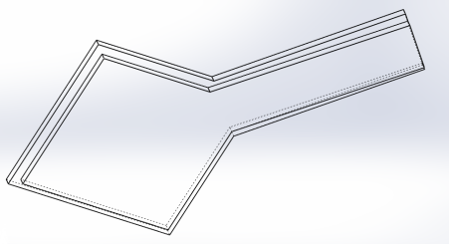
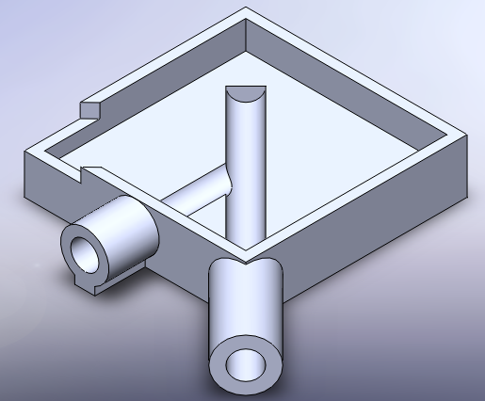
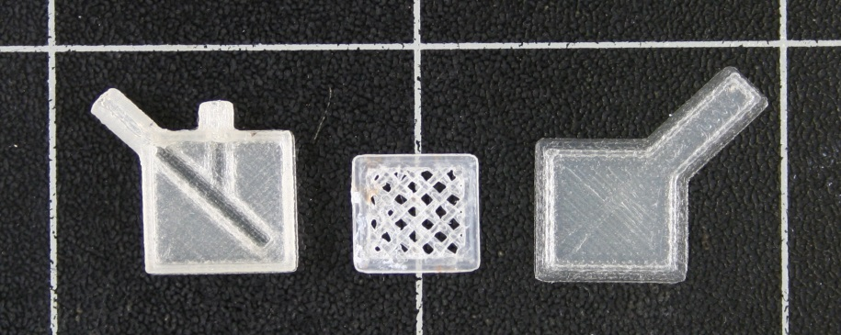
The materials used to manufacture the batteries must therefore be biocompatible and bioabsorbable with a degradation time compatible with the device operating period, while, at the same time, having good electrochemical characteristics in order to obtain batteries with sufficient performance. These materials must resist biodegradation at 37°C, while still providing the power required by the battery, and eventually degrade once the mission completed. The objective of this work is to highlight the feasibility of such batteries using simple manufacturing techniques and to study areas for improvement.
Figure 1 : Case CAD Design and 3D printed result
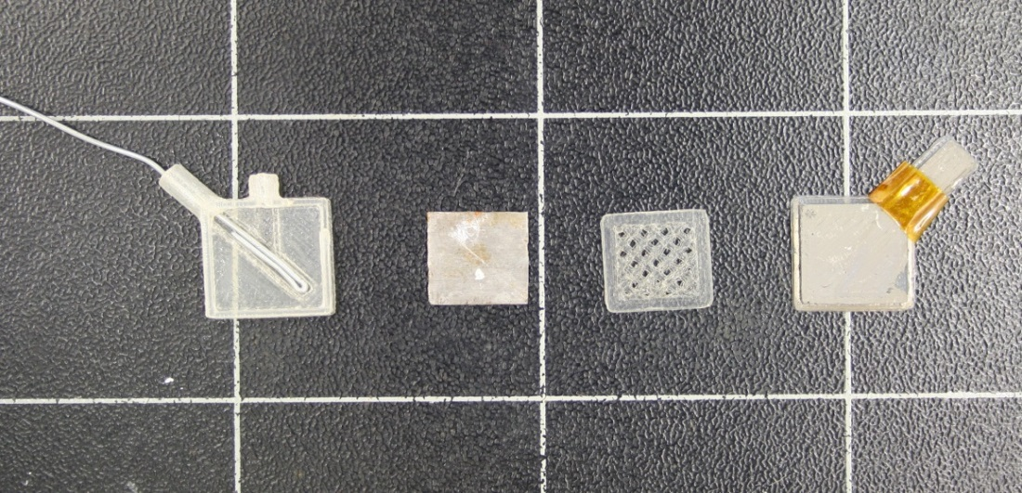
The battery casings were made by 3D printing with PLA which is a biodegradable polymer (cf. Figure 1). This technique allows the production of small batteries that can then be tested to obtain their electrical characteristics. The cathode consists of a thin soft iron plate (10x10x0.1 mm³). The anode is made of magnesium deposited by vacuum evaporation. This material is nontoxic in the body and has a very negative redox potential (-2 V/NHE) while not being too reactive (cf. Figure 2). The electrolyte is based on PBS (Phosphate Buffer Saline), a solution with a composition similar to the physiological liquid. A biocompatible corrosion inhibitor (sodium benzoate) is added in order to avoid the spontaneous corrosion of the magnesium in contact with water without load current. Otherwise, the battery would age very fast even without using it.
Figure 2 : Battery assembly (from left to right, the case and contact iron wire; the iron cathode; a 3D printed PLA separator; PLA cover covered by vaccum evaporated magnesium as an anode)
Characterization of the battery degradation period and electrochemical performances.
A significant part of the work was devoted to the observation of the degradation of the various components of the battery in physiological fluid at body temperature. The electromotive force of the battery is about 1 V. Higher voltages can be reached by putting cells in series.
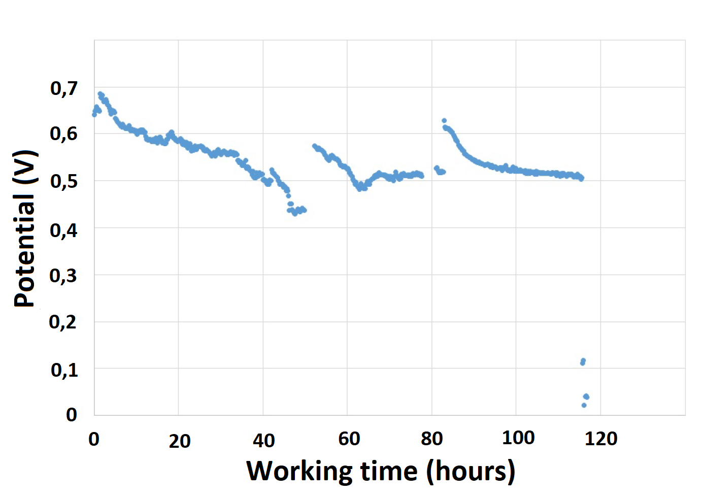
The aim was to have information on the degradation kinetics of the components, which will later allow the dimensioning of the stacks.
Figure 4 : discharge characteristic of a battery delivering a 100 µA/cm² current [2]
Young’s modulus (MPa)
Figure 3 : variation of PLA Young modulus
Since PLA has an ester group, it is essentially degraded by hydrolysis when immersed in an aqueous medium. After this immersion, the water molecules diffuse into the polymer and then attack the ester groups. This will result in a drop of the mechanical properties. Figure 3 shows the evolution of Young’s modulus while immersing in 37 °C water. As this device is not supposed to undergo high mechanical constraints, it is clear that, with the PLA thicknesses used, PLA deterioration will not be critical for several months [1]. As the most oxidable of the two metals, magnesium degradation is the most critical one.
In practice, the battery is able to deliver a 500 mV potential while delivering a100 µA/cm² current (cf. Figure 4). The battery should be able to last longer, but localized corrosion isolates the magnesium electrode from the circuit connecting it to the measuring system, and thus prevents a longer discharge time while there is still magnesium inside the device [3]. It is possible to put these batteries in series to increase output potential, in order to generates enough current to power a small sensor.
Conclusion
The feasibility of making these bioresorbable temporary batteries by 3D printing with PLA has been demonstrated. The electromotive force of the batteries obtained is about 1 V at the beginning of their life and decreases to 0.5 V for a constant current output of 0.1 mA for a maximum current of about 1 mA. Their lifespan is limited by magnesium corrosion, which leads to additional magnesium consumption even when the battery is not used. To reduce this corrosion, various PBS-based electrolytes with or without inhibitor were studied.

[1] C. Vieira; J. C. Vieira; R. M. Guedes; T. Marques, Mater. Sci. Forum, 2010, vol. 636–637, pp. 825–832.
[2] A. Hendrickx, “Réalisation et étude de piles biorésorbables,” UMONS - Faculté Polytechnique de Mons, 2017.
[3] H. Charlier, “Etude et réalisation de piles biorésorbables” UMONS - Faculté Polytechnique de Mons, 2016.

