How the understanding of photoheterotrophic assimilation of valerate by Rhodospirillum rubrum can improve the production of the high quality PHA
Guillaume Bayon-Vicente^{1*}, Sarah Zarbo¹, Adam Deutschbauer², Ruddy Wattiez¹, Baptiste Leroy¹
¹ Laboratory of Proteomics and Microbiology, Research Institute for Biosciences, University of Mons, Mons, Belgium
²Environmental Genomics and Systems Biology Division, Lawrence Berkeley National Laboratory, Berkeley, California, USA
Running title
Photoheterotrophic assimilation of valerate and PHA production by Rs. rubrum
*Corresponding author:
Bayon-Vicente Guillaume, Laboratory of Proteomics and Microbiology, Research Institute for Biosciences, 20 place du Parc, University of Mons, Mons, Belgium. E-mail: guillaume.bayon-vicente@umons.ac.be, phone number: +3265373311
E-mail addresses: Guillaume.bayon-vicente@umons.ac.be; sarahzarbo@gmail.com; amdeutschbauer@lbl.gov; ruddy.wattiez@umons.ac.be; baptiste.leroy@umons.ac.be.
Abstract word count: 276
Main text word count: 5433

Abstract

Purple non sulphur bacteria are mainly studied for their high metabolic versatility and are more and more regarded for industrial applications in bioplastics, pigment or biomass production. In order to optimize the yield of future biotechnological processes, the assimilation of different carbon source by Rhodospirillum rubrum (Rs. rubrum) has to be understood. As they are released from several fermentation processes, volatile fatty acids (VFAs) represent a promising carbon source in the development of circular industrial applications. In this study, we analysed the valerate phototrophic assimilation as this compound has already been linked to the production of copolymers of polyhydroxyalkanoates (PHA). To obtain exhaustive characterization of the photoheterotrophic metabolism of Rs. rubrum in the presence of valerate, we combined phenotypic, proteomic and genomic approaches. We obtained evidences that valerate is first cleaved into acetyl-CoA and propionyl-CoA prior to assimilation which depends on the presence of bicarbonate ions. Our proteomic data showed that the photoheterotrophic assimilation of valerate induces an intracellular redox stress which is accompanied by an increased abundance of the phasins (main proteins present in PHA granules). Genomic and enzyme inhibition data showed that a functional methylmalonyl-CoA pathway is essential for the photoheterophic assimilation of valerate. Finally, we observed a significant increase in the production of the high quality copolymer P(HB-co-HV) presenting high percentage of HV monomer. Moreover, an increase in PHA content was obtained when bicarbonate ions were progressively added to the medium. The experimental conditions used in this study suggest that the redox imbalance is responsible for the PHA production. Those findings also reinforce the idea that PNSB are suitable for the PHA production through another strategy than the well-known feast and famine process.

Introduction

Rhodospirillum rubrum is a purple non-sulphur bacterium (PNSB) belonging to the α-proteobacteria group. During decades, Rs. rubrum has been studied for the understanding of photoheterotrophic metabolism. Indeed, this bacterium is able to assimilate a broad range of carbon sources during anoxygenic photosynthesis ^{1,2}. Among those carbon sources, volatile fatty acids (VFAs) are studied in the biotechnology field as they are cheap and easily available. The use of these by-products issued from fermentation bioprocesses could also increase the circularity of the bioindustry. As acetic acid is the most abundant VFA resulting from fermentation processes, it has been broadly studied and lots of papers are available on its assimilation^{3–9}. It is now well accepted that, in isocitrate lyase gene lacking organisms (icl⁻)¹⁰ such as Rs rubrum, an alternative pathway, the ethylmalonyl-CoA pathway is used⁸ for acetate photoassimilation. The role of this pathway have been first characterized by Erb and his group^{6,7}. Beside the EMC pathway, the use of additional metabolic routes, such as the isoleucine biosynthesis and degradation pathways (MBC pathway) or the pyruvate ferredoxin oxydoreductase (PFOR), remains obscure and further studies are still needed to attest the involvement of them in the acetate assimilation^{8,9,11,12} .
Valerate constitutes the fourth most abundant VFAs resulting from the majority of the fermentation processes^{13,14}. However, some studies revealed that the fermentation of pig feces resulted in equal proportions of each VFAs or even higher proportion of valerate than the other VFAs¹⁵. Moreover, some processes deliberately enriched their fermentation effluent in valerate in order to induce the production of the high quality polymer P(HB-co-HV)¹⁶ further demonstrating the importance of understanding the photoheterophic assimilation of this VFA by Rs. rubrum. Despite this interesting feature, only few studies related to the photoheterotrophic assimilation of valerate are available¹⁷. In this study, it was stated that all Rhodospirillaceae were able to photoassimilate valerate, but no information was given about the metabolic pathway used for that. In Escherichia coli, the assimilation of valerate has been reported to rely on the ATO system responsible of the short chain fatty acid degradation¹⁸.
The use and littering of petroleum-based plastics is one of the major issues that human-being has to face. Polyhydroxyalkanoates (PHAs) represent good candidates to replace conventional plastics as they exhibit physico-chemical properties close to oil-based plastics^{19–21} with the advantage of being biobased and biodegradable^{22,23} . However, the production costs today still limit the economic sustainability of the PHA industry. In some processes, the carbon source may account for more than 50% of the total production costs²⁴. The use of cheap substrates such as VFAs may thus represent a way to significantly decrease these costs. Moreover, the nature of the carbon source influences the type and composition of PHAs produced. In this context, the use of carbon sources with odd number of carbons, such as propionate or valerate, is known to induce the production of the co-polyester poly-3-hydroxybutyrate-co-3-hydroxyvalerate (P(3HB-co-3HV))^{25,26} which exhibits enhanced physico-chemical properties with higher elasticity and lower melting point and crystallinity²³.
In this paper, we investigated the valerate assimilation by Rs. rubrum S1H using global analyses of the metabolism (proteomic and functional genomic approaches) as well as targeted analyses using knock out mutant and chemical inhibition of key enzymes. Our results demonstrated that the presence of bicarbonate ions is mandatory for the assimilation of valerate. We also showed that valerate was first cleaved into propionyl-CoA and acetyl-CoA. Our whole metabolism analyses revealed that a fully functional methylmalonyl-CoA pathway is mandatory for photoheterotrophic assimilation of valerate but also that the the ethylmalonyl-CoA pathway was not necessary for the assimilation of acetyl-CoA issued from valerate cleavage. It suggests that other pathways such as the pyruvate ferredoxin oxydoreductase (PFOR) or the isoleucine biosynthesis may take part in this assimilation process as it was already suggested by our previous studies^{8,9,11,12}. We also investigated the PHA production by Rs. rubrum highlighting the production of copolymers with outstanding HV monomer percentage even in conditions of full nutrient availability. We finally highlighted the capacity of controlling the composition of polymers by sequential addition of VFAs, which would represent a major advance in controlling biopolymers production.

Materials and methods

Bacterial strain, medium composition and cultivation conditions

The strain Rhodospirillum rubrum S1H (ATCC25903) as well as the Δccr::km^{R} strain were cultivated in medium as described previously^{8,9}. The medium was supplemented with valerate (24.9 mM) as carbon source, NH₄Cl (35 mM) as nitrogen source, biotin (0.06 mM) and defined amount of added bicarbonate (3 or 50 mM). Stock cultures were cultivated in SMN (supplemented malate ammonium) medium. Precultures used here were all cultivated in the presence of succinate as carbon source. Cultures were submitted to 50 µmol photons/m² s (Sencys; 10 W; 100 lumens; 2,650 K). The upper gaseous phase was flushed using pure N₂ and flasks were hermetically sealed
Growth was followed through optical density (OD_{680nm}) measurement. Rhodospirillum rubrum was cultivated under anaerobic phototrophic condition. Cultures were inoculated at a starting OD_{680nm} between 0.450 and 0.550 and incubated at 30°C with rotary shaking at 185 rpm. Five clonal biological replicates were used for each culture conditions. Cell dry weight was approximated using a standard (conversion factor: CDW= 0.6521*OD_{680nm}).

Mutant strain control

The presence of ccr and kmR cassette gene in both WT and mutant strain was verified through PCR and electrophoresis gel. Genomic RNA-free DNA was isolated from 500 µl of bacterial culture using the QIAamp DNA Mini Kit (QIAGEN) according to the manufacturer’s instructions. The concentration and quality of the isolated DNA samples were measured using a BioSpec-Nano (Shimadzu) micro-volume spectrophotometer based on UV spectra. The samples were adjusted to a concentration of 1 ng/µl. Extracted DNA was then submitted to PCR using primer specific for Crotonyl-CoA reductase/carboxylase (Ccr-Rru_A3063) and Kanamycin Resistance gene (KmR) ⁹. DNA was then submitted to electrophoresis and the presence of targeted genes was revealed using Gel Red.

Monitoring of the carbon source concentration in the medium

Culture supernatants were obtained from culture samples after centrifugation at 16,000 g for 10 min at 4°C using a Shodex Sugar SH1011 column (300 mm x 8 mm) with aqueous H₂SO₄ (0.01N) as the mobile phase as described previously⁸. Valerate and succinate concentrations were determined by integration of their specific peak and comparison with a reference curve prepared with the corresponding standard. Detection was performed using a refractometer.

Polyhydroxyalkanoate extraction and quantitation

PHAs were isolated as described previously²⁷ with some modification. Briefly 500 µl of culture were centrifuged (8000 rpm, 15 minutes) and stored at -20°C till analyse. PHAs were extracted and methanolysed by resuspending pellets in 500 µl of chloroform and 2 mL of methanolysis solution consisting in UHPLC methanol: concentrated HCl (90:10). The methanolysis solution also includes 0.1 mg/ml of 3-methylbenzoic acid as internal standard. Mixture was then incubated at 100°C during 2 hours before being cooled down on ice. 2mL of distilled water was then added and the bottom chloroformic part was recovered and analysed by GC-MS (Shimadzu GC-MS QP2010S).

Mutant fitness assay

The mutant library was produced following the protocol described by Wetmore et al.²⁸ and explained in De Meur et al. ⁹.
The mutant fitness assays were performed in 5 replicates starting with 5 different glycerol stocks of the mutant library. Each aliquot of the mutant library was independently amplified in SMN with 50 µg/ml kanamycin under dark aerobic conditions. The amplified library was rinsed and resuspended in defined medium to reach a starting OD_{680nm} of 0.1. Samples of biomass were collected at T0 and after 5 generations, and the genomic DNA was extracted using the QIAamp DNA Mini Kit (Qiagen). The concentration and purity of the extracted DNA were assessed with a BioSpec-Nano (Shimadzu Biotech) before storage at -80°C. We performed DNA barcode sequencing (BarSeq) as described by Wetmore et al.²⁸ to quantify the bar codes and, consequently, the abundance of each mutant in each experimental condition. The strain fitness was determined as the normalized log2 ratio of bar code counts between samples after 5 generations and the “time-zero” reference samples. Gene fitness was calculated as the weighted average of the individual strain fitness values for a given gene, as described.

Proteomic analysis

Bacteria were harvested via centrifugation (16,000 g, 4°C) at the beginning of the exponential phase (OD_{680nm}:0.9-1). Proteins were extracted using guanidinium chloride (6 M) and ultrasonication (3*10 sec, IKA U50 sonicator (Staufen, Germany), amplitude 40%). Protein concentration was determined using Bradford method²⁹ with Bovine Gamma Globulin as standard. 50 µg of proteins were reduced (DTE), alkylated (iodoacetamide) and finally precipitated overnight using acetone. The obtained proteins pellets were then solubilised using 50 mM ammonium bicarbonate containing 1 µg of trypsin and incubated overnight at 37°C. Digestion was stopped by adding 0.1% formic acid (v/v, final concentration).
Protein identification and quantification were performed following a label-free strategy on a UHPLC HRMS platform (Eksigent 2D ultra-AB SCIEX TripleTOF™ 5600). Peptides (2 µg) were separated in a 25 cm C18 column (Acclaim PepMap100, 3 µm, Dionex) using a linear acetonitrile (ACN) gradient [5-35% (v/v), in 120 min] in water containing 0.1% (v/v) formic acid at a flow rate of 300 nl.min-1. Data were acquired in a data-dependent acquisition mode (DDA). Search parameters included differential amino acid mass shifts for carbamidomethyl cysteine, oxidized methionine, all biological modifications, amino acid substitutions and missed trypsin cleavage sites. ProteinPilot Software (v4.1) was used to perform database searches against the UniProt database, restricted to Rhodospirillum entries (ATCC11170). Area under the XIC curves of peptides were computed using PeakViewTM 2.1 (ABSciex, USA) and individually normalized based on a summed area of all peptides for each sample. Five biological replicates were considered for each condition. Markerview™ 1.2.1 (ABSciex, USA) was used for statistical treatment of the data.

Results and discussion

3.1 Bicarbonate ions are essential for growth in the presence of valerate

In order to first characterise the photoheterotrophic assimilation of valerate, Rhodospirillum rubrum S1H (Rs. rubrum) was cultivated with valerate as sole source of carbon. As bicarbonate ions are already known to act as limiting factor in VFA assimilation such as acetate, propionate or butyrate^{9,11,30–32} but are also needed to adapt to certain culture conditions¹², we tested the effect of addition of low and high concentration of bicarbonate ions (3 and 50 mM HCO₃⁻) in the medium and used succinate as the control condition. As shown in Fig. 1A, phototrophic growth of Rs. rubrum with valerate as sole carbon sourcesupplemented with low concentration of bicarbonate ions stopped at an OD_{680nm} of 1.5 ± 0.2 whereas growth with high concentration of bicarbonate ions reached an OD_{680nm} of 5.9 ± 0.1 (Fig. 1A). Interestingly, identical carbon supply (124 mM of C equivalent and 50 mM HCO₃⁻) led to higher biomass production in the presence of valerate than in the presence of succinate (calculated biomass concentration: Val = 3.73 mg/mL vs Succ = 2.40 mg/mL). Indeed, 1.79±0.08 mg of biomass were accumulated per mg of available carbon in the presence of valerate whereas 1.48±0.03 mg of biomass were accumulated per mg of available carbon in the presence of succinate (p-value < 0.001), suggesting significant assimilation of bicarbonate ions under valerate condition. In order to attest the essentiality of bicarbonate ions during photoheterotrophic growth with valerate as sole source of carbon, Rhodospirillum rubrum was cultivated in the presence of valerate with only 3mM of added bicarbonate ions. As observed previously, the growth stopped around OD_{680nm} ~ 1.5. Once growth stopped, 10 mM of bicarbonate ions (final concentration) were added to the culture and growth was monitored. The growth immediately restarted after this addition of bicarbonate ions reaching a final OD_{680nm} comparable to those observed with high bicarbonate supplementation (Fig. 1B). The essentiality of bicarbonate ions for assimilation of acetate, propionate or butyrate had already been documented^{11,12,31,33}. As the valerate constitutes the most reduced VFAs compared to the biomass (redox state valerate:-2.5³⁴; biomass: -0.5³⁵), the requirement of bicarbonates ions could be linked to the redox stress induced by the photoheterotrophic assimilation of valerate.
Consistently, the proteomic analysis revealed that the Ribulose 1,5-Bisphosphate Carboxylase/Oxygenase (RuBisCO), main enzyme of the Calvin-Benson-Bassham (CBB) cycle, was more abundant (Rru_A2400; fold change = 1.71, p-value = 0.01, #peptide = 89) during photoheterotrophic assimilation of valerate compared to succinate. This observation further corroborates the strict necessity of bicarbonate ions for the assimilation of valerate and the higher biomass productivity. Moreover, the mutant fitness assay showed that a functional CBB cycle was essential in both conditions, as already demonstrated for succinate³⁶. This observation corroborates the results obtained during the phenotypic analyses. Considering this observation, it seems that HCO₃⁻ are, at least partly, consumed through the Calvin-Benson-Bassham cycle, suggesting a role of this pathway in the dissipation of the reduced equivalent generated during the photoheterotrophic assimilation of valerate.

3.2 The photoheterotrophic assimilation of valerate induces a cellular redox stress and an increased PHA production

The proteomic analysis showed the higher abundance of four proteins related to stress handling and redox homeostasis in the presence of valerate. Unfortunately, only one of the gene encoding for those proteins (stress protein, rru_A0894) was present in our mutant fitness dataset. The analysis of the fitness value for this gene revealed that it was essential in both conditions (Table 1). Beside proteins implicated in the redox homeostasis, proteomic analysis also revealed higher abundance of proteins involved in the metabolism of PHAs, such as phasins in the presence of valerate. One the two phasins quantified in the proteomic analysis (Rru_A2817) exhibited a fold change of 48.24 compared to succinate condition which depicts a presence/absence phenomenon. The second phasin (Rru_A3283) was found to be twice more abundant in the presence of valerate than under succinate condition (fold change =2.06, p-value = 0.027, # peptides = 80). We also highlighted the higher abundance of the uncharacterised protein Rru_A2111 (fold change = 3.56, p-value = 2.24E-06, # peptides = 27) which was recently described as potential phasin by Narancic and her group³⁷. Nevertheless, the exact role of these proteins remain unclear as they exhibit both a function in PHB granule mobilisation and a role in increasing the number of PHB granule in the cell³⁸. Moreover, the polyhydroxyalkanoates depolymerase, responsible of the degradation of PHA, showed a lower abundance compared to succinate condition (Table 1).
Conversely to the proteomic results which suggested the involvement of PHA synthesis in the adaptation of Rs. rubrum to the growth with valerate as sole carbon source, none of the genes coding for the above mentioned proteins was observed as essential for the photoheterotrophic assimilation of valerate in the genome-wide mutant fitness assay. It may be explained by the addition of high concentration of bicarbonate ions in the medium used to perform this experiment. Indeed, both the PHA production and the CBB cycle, are known to act as electron sinks^{12,31,36,39–43}. It thus suggests that PHA production may be not essential as soon as another electron sink metabolism, such as the CBB cycle, is available. Interestingly, genes coding for enzymes involved in the conversion of acetyl-CoA into (S)-3-hydroxybutyryl-CoA were highlighted as essential for phototrophic assimilation of valerate by Rs. rubrum. One of these enzymes, the 3-hydroxybutyryl-CoA dehydrogenase (Rru_A3079), is known to consume reduced equivalents (Fig 2, see supplementary Table 1) and might thus take part in the handling of the redox poise.
The higher abundance of phasins combined to a lower abundance of PHA depolymerase highlighted by proteomic results suggested an increased production of PHA in valerate conditions. Moreover, mutant fitness assays showed that the (S)-3-hydroxybutyryl-CoA dehydrogenase was essential in the presence of valerate. In order to validate the increased PHA production during valerate assimilation, PHA content of the biomass was monitored along the growth curve under valerate and succinate conditions. As expected, an increased PHA production was observed during photoheterotrophic growth of Rs. rubrum in the presence of valerate (reaching up to 14.20±1.37 % of the biomass dry weight after 30 hours of culture) (Fig. 4A) whereas PHA content was under the limit of detection under succinate condition (data not shown). The abundance of PHA produced under valerate was rather low. Indeed, Cerrone et al. performed PHA content analyses on P. putida and observed that this bacterium was able to accumulate from 19 to 24 % of PHA CDW in the presence of valerate as sole carbon source⁴⁴. We hypothesized that PHA production was used as an electron sink and that their production could be curbed by other electron sinking processes. As such, the presence of bicarbonate ions and its assimilation through the Calvin-Benson-Bassham cycle could represent a major competitor pathway to the PHA production. Indeed, proteomic and mutant fitness assay data showed that CBB cycle was probably involved in the metabolism of valerate. Therefore, we attempted to reduce the level of HCO₃⁻ in the cultures in order to reduce as much as possible the electron sink role of the CBB cycle. Cultures were started in valerate containing medium with low concentration of HCO₃⁻ (3mM) which was only resupplied (up to 3mM in the medium) when a growth arrest was observed. This resulted in a sequential growth behaviour restarting each time we added bicarbonate ions in the medium (Fig. 4B). Each addition of HCO₃⁻ was thus preceded by a growth arrest and a reduced valerate uptake rate. Interestingly, each of the transient stationary phases this procedure created was characterised by an increase of the intracellular PHA content (Fig. 4B). By starving the CBB cycle from bicarbonate ions, Rs. rubrum accumulates up to 22.57±5.89% of the cell dry weight after 70 hours of culture. Indeed, this content significantly increased during the first transient stationary phase (T: 27h; PHA:10.86±2.58% CDW; T:70h; PHA: 22.57±5.89% CDW, p-value<0.05). The second transient stationary phase, which correspond to the second bicarbonate starvation of the culture (T:101h), was also accompanied by a significant (p-value < 0.05) PHA content increase of 133% rising from 7.98±1.94% (T101h) to 18.61±2.94% (T174h) CDW (Fig 4B). Interestingly, PHA content obtained after both stationary phases was significantly higher (p-value <0.05) than PHA content observed in the presence of excess HCO₃⁻ (PHA_{excessHCO3}-: 14.20±1.37%; PHA_{3mMfirst stationary phase}: 22.57±5.89%; PHA_{3mMsecond stationary phase}: 18.61±2.94%, p-value < 0.05). In opposition to what is usually observed ^{45–49}, PHA increased production is not triggered through a feast and famine process, suggesting that the PHA production could be linked to intracellular redox unbalance. Indeed, the depletion of bicarbonate ions in the medium represents a non-favourable redox environment for Rs. rubrum cultivated in the presence of valerate. The concomitant increase in the PHA content and its further mobilization after HCO₃⁻ repletion demonstrates that PHAs are produced by Rs. rubrum to deal with the redox imbalance imputed to the photoheterotrophic assimilation of valerate as already hypothesised^{12,40,43}.

3.3 The acetyl-CoA and propionyl-CoA assimilation pathways highlighted as potential pathways involved in photoheterotrophic assimilation of valerate

3.3.1 The β-oxidation as first step of the photoheterotrophic assimilation of valerate

The literature hinted that following its activation into valeryl-CoA, the valerate (C5) is cleaved into acetyl-CoA (C2) plus propionyl-CoA (C3) through β-oxidation^{18,50} . As such, we searched our proteomic and mutant fitness dataset for β-oxidation related proteins or genes respectively. The mutant fitness analysis revealed the essentiality of the genes rru_A1308, rru_A3801, rru_A1309 and rru_A1310 coding for an acyl dehydrogenase, enoyl dehydratase, 3-hydroxyacyl-CoA dehydrogenase and acetyl-CoA-C-acyltransferase respectively (rru_A1308: fitness value Succ: 0.03, Val: -0.52; rru_A3801: fitness value Succ: -0.25, Val: -0.92; rru_A1309: fitness value Succ: -0.18, Val: -1.00 and rru_A1310: fitness value Succ: 0.10, Val: -0.72). Collectively, those enzymes may link the valerate uptake to the production of acetyl-CoA and propionyl-CoA. However, further investigations are required to understand the absence of change in the abundance or even the downregulation highlighted by the proteomic analysis for these enzymes (Rru_A1308: p-value: 0.16, fold change Val/Succ: 0.77; Rru_A3801:p-value: 0.51, fold change Val/Succ: 1.11; Rru_A1309: p-value: 0.0035, fold change Val/Succ: 0.65; Rru_A1310: 0.00075, fold change Val/Succ: 0.49).

3.3.2 Acetate related pathways are highlighted through proteomic analysis for photoheterotrophic assimilation of valerate

The proteomic data revealed that several enzymes already associated with the acetate metabolism such as the enzymes of the ethylmalonyl-CoA (EMC) pathway (Rru_A3062, fold change = 1.65, p-value = 0.05, #peptides = 9; Rru_A3063, fold change = 6.35, p-value = 0.00012, #peptides = 26; Rru_A3064, fold change = 2.53, p-value = 0.01, #peptides = 42) or the pyruvate ferredoxin oxydoreductase (PFOR) (Rru_A2398, fold change = 1.51, p-value = 0.04, #peptides = 125) (Fig. 2) were differentially regulated in the presence of valerate and could also be involved in the photoassimilation of valerate. The EMC pathway was shown to be essential for the photoheterotrophic assimilation of acetate by our group ^{8,9} or others^{6,7} and it is now established that this pathway acts as an anaplerotic pathway during the phototrophic assimilation of acetate. The PFOR is known to convert acetyl-CoA into pyruvate and has also been highlighted by previous proteomic analyses ^{8,9} ^{2,51,52} in the presence of acetate. Besides proteins which implication in acetate assimilation has been well established, the proteomic analysis revealed the higher abundance of proteins belonging to the branched chain amino acid (BCAAs) biosynthesis and degradation pathways, which represent a more controversial assimilation pathway (Rru_A0468, fold change = 2.18, p-value = 0.05, #peptides = 9; Rru_A0469, fold change = 1.61, p-value = 0.01, #peptide =42; Rru_A2223, fold change =4.95, p-value = 0.016, #peptides = 24; Rru_A1946, fold change = 1.74, p-value = 0.04, #peptides = 2; MerR transcription regulator Rru_A1994, fold change = 1.75, p-value = 0.04, #peptides= 4) (Fig. 2). The implication of BCAA biosynthesis and degradation pathways have already been proposed as potential assimilation pathways in the presence of butyrate¹¹ or acetate^{8,53}. Recently, a sudden increase in light intensity highlighted that the isoleucine biosynthesis may be implicated in high light intensity tolerance¹² further reinforcing the implication of this pathway in managing the redox balance as already proposed^{54,55}. This latter hypothesis is supported by the present redox issue observation but would require further dedicated researches.
However, contrary to what was observed in proteomic data, the genome-wide mutant fitness assay revealed that the ethylmalonyl-CoA pathway was not essential for valerate photoassimilation by Rhodospirillum rubrum (Fig. 2, see supplementary table 1). It could indicate that the observed upregulation of the enzyme of the EMC could be imputed to side regulation of the EMC pathway due to the presence of acetyl-CoA following cleavage of valerate, but that this pathway is not extensively used during valerate photoassimilation.
In order to clearly address the essentiality of the EMC pathway, we cultivated our Δccr:Km^{R} (lacking the gene coding for the key enzyme of the EMC pathway) in the presence of valerate as sole source of carbon. It revealed that the EMC pathway was not essential for the growth of Rs rubrum in the presence of valerate (Fig. 3A) confirming genome-wide mutant fitness assay. The genotype of the mutant strain was confirmed using PCR analysis (see supplementary figure 1).

3.3.2 The methylmalonyl-CoA pathway is essential for the photoheterotrophic assimilation of valerate

The assimilation of valerate through acetyl-CoA and propionyl-CoA involves that a higher activity of the propionyl-CoA assimilation pathway (the methylmalonyl-CoA pathway-MMC)^{56–58} should be observed under valerate conditions. However, enzymes of the MMC pathway were not upregulated under valerate condition, as revealed by proteomic analysis. Many groups have already observed that propionyl-CoA could be formed from succinate ^{59–61}, which could impair the detection of increased abundance of enzymes of the MMC pathway. Interestingly, the mutant fitness analysis highlights that the two subunits of two proteins implicated in propionyl-CoA assimilation pathway, the propionyl-CoA carboxylase and the methylmalonyl-CoA mutase(rru_A0052; rru_A0053; rru_A2479 and rru_A2480), are essential for the phototrophic assimilation of valerate but not of succinate (Fig. 2, see supplementary table 2). Those genes were already demonstrated as essential for propionyl-CoA assimilation ^{56,62,63}. Those results suggest that the production of propionyl-CoA represents a major step for the valerate assimilation. One hypothesis explaining the essentiality of the MMC, whereas the EMC is not, is that propionyl-CoA assimilation pathway could represent an anaplerotic pathway for the TCA cycle as it yields succinate, the EMC being no more essentials to fill this role. In order to attest the essential role of the methylmalonyl-CoA pathway in valerate assimilation, itaconic acid was used to inhibit the propionyl-CoA carboxylase (Rru_A0052/A0053)⁶². Growth of Rs. rubrum in the presence of succinate as main source of carbon and 20 mM of itaconic acid confirmed the absence of toxicity of itaconate as already shown previously by Berg et al.⁶². As presented in Fig. 3B, the addition of 20 mM of itaconic acid impaired the growth of Rs. rubrum in the presence of valerate either for the wild-type strain or for the Δccr::km^{R} strain confirming that the methylmalonyl-CoA pathway was essential for the assimilation of valerate.
The assimilation of propionyl-CoA yielded succinyl-CoA that can be converted into oxaloacetate and α-ketoglutarate using the oxidative and reverse TCA cycle, respectively. The assimilation of this C3 compound thus acts as an anaplerotic pathway. This key stone role in metabolism is commonly assumed by the EMC pathway in Rs. rubrum, but EMC has been shown to be non-essential under valerate condition Our results also revealed that the pyruvate ferredoxin oxydoreductase, rru_A2398, was essential for phototrophic growth in the presence of valerate (Fig. 2, see supplementary table 3), indicating that acetyl-CoA could be converted into pyruvate as this reaction is driven in this direction in anaerobic environment⁵¹. Moreover, we observed the essentiality of some enzymes of the BCAA biosynthesis pathway (Fig. 2, see supplementary table 3 and 4) for photoheterotrophic assimilation of valerate, further corroborating the proteomic analysis and previous studies^{8,11,12,53}. The acetyl-CoA arising from the cleavage of valerate is thus redirected to other pathways than the EMC, such as the BCAA biosynthesis pathway, PHA production or the PFOR. These pathways could help balancing the redox pool state. Whereas the implication of PHA production in redox homeostasis is well accepted now, the involvement of BCAA biosynthesis pathway as an electron sink is still controversial. However, this pathway was already highlighted during the photoheterotrophic assimilation of other reduced VFAs such as acetate⁸, butyrate¹¹ or even after a sudden increase in light intensity¹². Altogether, the data obtained previously and in this study hinted that BCAA biosynthesis pathway may act as another electron sink.

3.4 Polyhydroxyalkanoate characterization reveals the production of the high quality compound poly(3-hydroxybutyrate-co-3-hydroxyvalerate)

The use of carbon sources with odd number of carbon was often linked to the production of copolymers of poly(3-hydroxybutyrate-co-3-hydroxyvalerate) that represent high quality PHA, and exhibit outstanding physico-chemical properties^{25,64–67}. PHA quantitation already revealed a higher production of PHAs in the presence of valerate compared to succinate. Interestingly, PHA produced are copolymers of poly(3-hydroxybutyrate-co-3-hydroxyvalerate) (P(HB-co-HV)) with high monomeric percentage of 3-hydroxyvalerate (83.90±4.19% of the total polymer) (Fig. 4A). This outstanding proportion has never been observed by other groups producing this copolymer^{14,18,49,68–70}. Moreover, it is interesting to see that cultivating Rs. rubrum in bicarbonate ions limiting condition, which allowed to increase the total PHA content of biomass, had no significant impact on the 3-HV content (Fig 4B). The chemical and mechanical properties or biodegradability of PHAs are dependent of their monomeric composition as well as how they are concatenated^{64,71,72}. In that context, we attempted to control Rs. rubrum PHA production to obtain block co-polymers of P(3-HB-co-3-HV). Besides, the monomer content, the microstructure of the polymer plays a key role in the development of new polymer properties as the structure will capture the properties of each block and potentially develops new one^{73–75}. In order to explore the possibility of producing such block co-polymers, we cultivated Rs. rubrum in the presence of acetate as sole source of carbon (124 mM C equivalent) and we added 10 mM of valerate (50mM C equivalent) when culture reached mid-log phase (DO_{680nm} ~ 2.0). Whereas HV content was negligible before valerate addition, HV monomer accumulated quickly in the PHA polymer reaching 7.02±1.04% of CDW only 11 hours after the addition of valerate in the medium, corresponding to a monomeric content of 14.51±2.41% of the total PHA. This result suggests that the production of PHA might be controlled by sequential addition of the suitable VFA in order to obtain the desired block copolymer for defined applications. However, it is rather complicated to precisely determine the presence of block copolymer using the approaches used here and requires further investigations to fully control the whole PHA production.

Conclusion

We demonstrated here that the presence of HCO₃⁻ is mandatory for the photoheterotrophic assimilation of valerate. We showed that the requirement of HCO₃⁻ was driven to the CBB cycle in order to regulate the redox balance (i.e. highly reduced carbon source and phototrophic metabolism). We have highlighted that following its activation in valeryl-CoA, the valerate was cleaved into acetyl-CoA and propionyl-CoA. Whereas, the ethylmalonyl-CoA pathway was not essential for the assimilation of valerate, a functional methylmalonyl-CoA pathway is mandatory. We have observed a polyhydroxyalkanoate production during photoheterotrophic metabolism of valerate that is undoubtedly used as an electron sink and that can reach up to 15% of the cell dry weight as PHA. Using a knowledge based optimisation process; we have improved the yield of this production to achieve a PHA content of more than 22% of the biomass by cultivating the bacteria in bicarbonate ions limiting conditions, which further reduced the activity of another electron sink, the Calvin-Benson-Bassham cycle. This type of observation has already been emphasized by our group following a sudden increase in light intensity. Finally, the characterization the PHA produced revealed an outstanding proportion of 3-hydroxyvalerate monomer content that has never been achieved in other studies. Moreover, we have displayed the possibility of controlling the monomeric microstructural composition of PHA by sequentially add the wanted VFA in order to produce the most suitable polymer.

.

Figure legends

Fig. 1:
(A) Growth of Rs. rubrum under succinate low HCO₃⁻ concentration (ο) and valerate low () and high (Δ) concentration of HCO₃⁻. (B) Growth of Rhodospirillum rubrum in the presence of succinate (ο) and valerate () with pulse of 10 mM bicarbonate ions. n=5
Fig. 2:
Schematic representation of the central carbon metabolism with proteins implicated in valerate assimilation as highlighted by proteomic data. The coloured squares indicate fold change between valerate and succinate condition ranging from red (proteins are less abundant in valerate condition) to green (proteins are more abundant in valerate condition). Non-significant proteins are represented by stripped markers. Peptide number used to identify the protein is represented next to the marker. Coloured circles indicate essentiality of gene based on fitness values obtained during mutant fitness assay n=5
Fig. 3:
(A) Growth of Rs. rubrum wild-type strain in the presence of succinate (ο) or valerate (Δ) as sole carbon source and Δccr::Km^{R} strain in the presence of valerate () as sole source of carbon.(B) Growth of Rs. rubrum wild-type strain in the presence of succinate (ο) or valerate (Δ) as sole carbon source and Δccr::Km^{R} strain in the presence of valerate () as sole source of carbon cultivated with the addition of 20mM of itaconic acid with the addition of 20mM itaconic acid (B). n=5
Fig. 4:
Rs. rubrum growth (upper figures) and PHA production (lower figures) observed in the presence of (A) valerate +50 mM HCO₃ and (B) valerate + progressive addition of 3 mM bicarbonate ions (vertical dotted lines). 3-hydroxybutyrate (light grey) and 3-hydroxyvalerate (dark grey) mononers content was determined theough GC-MS analysis. n=5
Fig. 5:
Rs. rubrum growth and VFA consumption (upper figure) and PHA production (lower figure) observed in the presence of acetate (upper figure-full circle dotted line) and after a pulse of valerate (upper figure-open square dotted line-vertical dotted line). 3-hydroxybutyrate (dark grey) and 3-hydroxyvalerate (light grey) mononers content was determined through GC-MS analysis. n=5

Table legends

Table 1 :
Proteins involved in the stress regulation and redox homeostasis highlighted by proteomic and mutant fitness analyses

Acknowledgement

This research was funded by the FRIA grant of Guillaume Bayon-Vicente (F.R.S-FRNS). This study was sponsored by the “Belgian Fund for Scientific Research (Grand equipment-F.R.S-FNRS).” The bioprofiling platform used for the proteomic analysis was supported by the European Regional Development Fund and the Walloon Region, Belgium.

References
1. Hunter, C. N., Daldal, F., Thurnauer, M. C. & Beatty, J. T. The Purple Phototrophic Bacteria. 28, (2009).
2. Tang, K. H., Tang, Y. J. & Blankenship, R. E. Carbon metabolic pathways in phototrophic bacteria and their broader evolutionary implications. Front. Microbiol. 2, 1–23 (2011).
3. Berg, I. a, Krasilnikova, E. N. & Ivanovsky, R. N. Investigation of the Dark Metabolism of Acetate in Photoheterotrophically Grown Cells of Rhodospirillum rubrum. Microbiology 69, 7–12 (2000).
4. Filatova, L. V. et al. A study of the mechanism of acetate assimilation in purple nonsulfur bacteria lacking the glyoxylate shunt: Acetate assimilation in Rhodobacter sphaeroides. Microbiology 74, 265–269 (2005).
5. Ivanovsky, R. N., Krasilnikova, E. N. & Berg, I. a. A proposed citramalate cycle for acetate assimilation in the purple non- sulfur bacterium Rhodospirillum rubrum. FEMS Microbiol. Lett. 153, 399–404 (1997).
6. Erb, T. J., Fuchs, G. & Alber, B. E. (2S)- Methylsuccinyl-CoA dehydrogenase closes the ethylmalonyl-CoA pathway for acetyl-CoA assimilation. Mol. Microbiol. 73, 992–1008 (2009).
7. Erb, T. J., Rétey, J., Fuchs, G. & Alber, B. E. Ethylmalonyl-CoA mutase from Rhodobacter sphaeroides defines a new subclade of coenzyme B12-dependent Acyl-CoA mutases. J. Biol. Chem. 283, 32283–32293 (2008).
8. Leroy, B., De Meur, Q., Moulin, C., Wegria, G. & Wattiez, R. New insight into the photoheterotrophic growth of the isocytrate lyase-lacking purple bacterium Rhodospirillum rubrum on acetate. Microbiology 161, 1061–72 (2015).
9. De Meur, Q., Deutschbauer, A., Koch, M., Wattiez, R. & Leroy, B. Genetic plasticity and redox homeostasis during acetate assimilation in Rhodopirillum rubrum S1H under photoheterotrophic conditions. (Submitted). Appl. Environ. Microbiol. (2018). doi:10.1128/AEM.02038-17
10. Kornberg, H. & Lascelles, J. The formation of isocitratase by the Athiorhodaceae. J. Gen. Microbiol. 23, 511–517 (1960).
11. De Meur, Q. et al. New perspectives on butyrate assimilation in Rhodospirillum rubrum S1H under photoheterotrophic conditions. BMC Microbiol. (2020).
12. Bayon-vicente, G., Wattiez, R. & Leroy, B. Global Proteomic Analysis Reveals High Light Intensity Adaptation Strategies and Polyhydroxyalkanoate Production in Rhodospirillum rubrum Cultivated With Acetate as Carbon Source. 11, 1–17 (2020).
13. Albuquerque, M. G. E., Eiroa, M., Torres, C., Nunes, B. R. & Reis, M. a M. Strategies for the development of a side stream process for polyhydroxyalkanoate (PHA) production from sugar cane molasses. J. Biotechnol. 130, 411–421 (2007).
14. Bengtsson, S., Werker, A., Christensson, M. & Welander, T. Production of polyhydroxyalkanoates by activated sludge treating a paper mill wastewater. Bioresour. Technol. 99, 509–516 (2008).
15. Yoshikawa, S. et al. Valerate production by Megasphaera elsdenii isolated from pig feces. J. Biosci. Bioeng. 125, 519–524 (2018).
16. Hao, J., Wang, X. & Wang, H. Overall process of using a valerate-dominant sludge hydrolysate to produce high-quality polyhydroxyalkanoates (PHA) in a mixed culture. Sci. Rep. 7, 1–11 (2017).
17. Janssen, P. H. & Harfoot, C. G. Phototrophic growth on n-fatty acids by members of the family Rhodospirillaceae. Syst. Appl. Microbiol. 9, 9–11 (1987).
18. Ho Gun Rhie & Dennis, D. Role of fadR and atoC(Con) mutations in poly(3-hydroxybutyrate-Co-3- hydroxyvalerate) synthesis in recombinant pha+ Escherichia coli. Appl. Environ. Microbiol. 61, 2487–2492 (1995).
19. Bugnicourt, E., Cinelli, P., Lazzeri, a. & Alvarez, V. Polyhydroxyalkanoate (PHA): Review of synthesis, characteristics, processing and potential applications in packaging. Express Polym. Lett. 8, 791–808 (2014).
20. Urtuvia, V., Villegas, P., Gonz??lez, M. & Seeger, M. Bacterial production of the biodegradable plastics polyhydroxyalkanoates. Int. J. Biol. Macromol. 70, 208–213 (2014).
21. Jeon, J. M. et al. Biosynthesis of poly(3-hydroxybutyrate-co-3-hydroxyhexanoate) (P(HB-co-HHx)) from butyrate using engineered Ralstonia eutropha. Appl. Microbiol. Biotechnol. 98, 5461–5469 (2014).
22. Keshavarz, T. & Roy, I. Polyhydroxyalkanoates: bioplastics with a green agenda. Curr. Opin. Microbiol. 13, 321–326 (2010).
23. Philip, S., Keshavarz, T. & Roy, I. Polyhydroxyalkanoates: biodegradable polymers with a range of applications. J. Chem. Technol. Biotechnol. 82, 1115–1121 (2007).
24. Klask, C., Raberg, M., Heinrich, D. & Steinbuchel, a. Heterologous Expression of Various PHA Synthase Genes in Rhodospirillum rubrum. Chem. Biochem. Eng. Q. 29, 75–85 (2015).
25. Pardelha, F., Albuquerque, M. G. E., Reis, M. A. M., Dias, J. M. L. & Oliveira, R. Flux balance analysis of mixed microbial cultures: Application to the production of polyhydroxyalkanoates from complex mixtures of volatile fatty acids. J. Biotechnol. 162, 336–345 (1970).
26. Otzen, C., Bardl, B., Jacobsen, I. D., Nett, M. & Brock, M. Candida albicans utilizes a modified β-oxidation pathway for the degradation of toxic propionyl-CoA. J. Biol. Chem. 289, 8151–8169 (2014).
27. Snell, K. D., Feng, F., Zhong, L., Martin, D. & Madison, L. L. YfcX Enables Medium-Chain-Length Poly ( 3-Hydroxyalkanoate ) Formation from Fatty Acids in Recombinant Escherichia coli fadB Strains. Society 184, 5696–5705 (2002).
28. Wetmore, K. M. et al. Rapid Quantification of Mutant Fitness in Diverse Bacteria by Sequencing Randomly Bar-Coded Transposons. MBio 6, 1–15 (2015).
29. Bradford, M. M. A rapid and sensitive method for the quantitation of microgram quantities of protein utilizing the principle of protein-dye binding. Anal. Biochem. 72, 248–254 (1976).
30. Muller, F. M. On the metabolism of the purple sulphur bacteria in organic media. Arch. Mikrobiol. 4, 131–166 (1933).
31. Laguna, R., Tabita, F. R. & Alber, B. E. Acetate-dependent photoheterotrophic growth and the differential requirement for the Calvin-Benson-Bassham reductive pentose phosphate cycle in Rhodobacter sphaeroides and Rhodopseudomonas palustris. Arch. Microbiol. 193, 151–154 (2011).
32. Richardson, D. J. et al. The role of auxiliary oxidants in maintaining redox balance during phototrophic growth of Rhodobacter capsulatus on propionate or butyrate. 2, 131–137 (1988).
33. Porter, J. & Merrett, M. J. Influence of Light Intensity on Reductive Pentose Phosphate Cycle Activity during Photoheterotrophic Growth of Rhodospirillum rubrum . Plant Physiol. 50, 252–255 (1972).
34. Gottschalk, G. Eo. (1986).
35. Mckinlay, J. B. & Harwood, C. S. Calvin Cycle Flux, Pathway Constraints, and Substrate Oxidation State Together Determine the H 2 Biofuel Yield in Photoheterotrophic Bacteria. MBio 2, 1–9 (2011).
36. McKinlay, J. B. & Harwood, C. S. Carbon dioxide fixation as a central redox cofactor recycling mechanism in bacteria. Proc. Natl. Acad. Sci. U. S. A. 107, 11669–11675 (2010).
37. Narancic, T., Scollica, E., Cagney, G. & O’Connor, K. E. Three novel proteins co-localise with polyhydroxybutyrate (PHB) granules in Rhodospirillum rubrum S1. Microbiol. (United Kingdom) 164, 625–634 (2018).
38. Handrick, R. et al. Unraveling the Function of the Rhodospirillum rubrum Activator of Polyhydroxybutyrate (PHB) Degradation: The Activator Is a PHB-Granule-Bound Protein (Phasin). J. Bacteriol. 186, 2466–2475 (2004).
39. Hauf, W. et al. Metabolic Changes in Synechocystis PCC6803 upon Nitrogen-Starvation: Excess NADPH Sustains Polyhydroxybutyrate Accumulation. Metabolites 3, 101–118 (2013).
40. Jin, H. & Nikolau, B. J. Role of genetic redundancy in polyhydroxyalkanoate (PHA) polymerases in PHA biosynthesis in Rhodospirillum rubrum. J. Bacteriol. 194, 5522–5529 (2012).
41. Gordon, G. C. & McKinlay, J. B. Calvin cycle mutants of photoheterotrophic purple nonsulfur bacteria fail to grow due to an electron imbalance rather than toxic metabolite accumulation. J. Bacteriol. 196, 1231–1237 (2014).
42. Rizk, M. L., Laguna, R., Smith, K. M., Tabita, F. R. & Liao, J. C. Redox homeostasis phenotypes in RubisCO-deficient Rhodobacter sphaeroides via ensemble modeling. Biotechnol. Prog. 27, 15–22 (2011).
43. Narancic, T. et al. Understanding the physiological roles of polyhydroxybutyrate (PHB) in Rhodospirillum rubrum S1 under aerobic chemoheterotrophic conditions. Appl. Microbiol. Biotechnol. (2016). doi:10.1007/s00253-016-7711-5
44. Cerrone, F. et al. Medium chain length polyhydroxyalkanoate (mcl-PHA) production from volatile fatty acids derived from the anaerobic digestion of grass. Appl. Microbiol. Biotechnol. 98, 611–620 (2014).
45. Santhanam, A. & Sasidharan, S. Microbial production of polyhydroxy alkanotes ( PHA ) from Alcaligens spp . and Pseudomonas oleovorans using different carbon sources. African J. Biotechnol. 9, 3144–3150 (2010).
46. Jendrossek, D. Polyhydroxyalkanoate granules are complex subcellular organelles (carbonosomes). J. Bacteriol. 191, 3195–3202 (2009).
47. Lee, H. O. J., Choi, M. H., Kim, T. U. N. & Yoon, S. C. Accumulation of Polyhydroxyalkanoic Acid Containing Large Amounts of Unsaturated Monomers in Pseudomonas fluorescens BM07 Utilizing Saccharides and Its Inhibition by 2-Bromooctanoic Acid. Appl. Environ. Microbiol. 67, 4963–4974 (2001).
48. Fradinho, J. C., Oehmen, A. & Reis, M. A. M. Photosynthetic mixed culture polyhydroxyalkanoate ( PHA ) production from individual and mixed volatile fatty acids ( VFAs ): Substrate preferences and co-substrate uptake. J. Biotechnol. 185, 19–27 (2014).
49. Page, W. J., Manchak, J. & Rudy, B. Formation of poly(hydroxybutyrate-co-hydroxyvalerate) by Azotobacter vinelandii UWD. Appl. Environ. Microbiol. 58, 2866–2873 (1992).
50. Jenkins, L. S. & Nunn, W. D. Genetic and molecular characterization of the genes involved in short-chain fatty acid degradation in Escherichia coli: the ato system. J Bacteriol 169, 42–52 (1987).
51. McNeely, K. et al. Characterization of a nifJ mutant of Synechococcus sp. strain PCC 7002 lacking pyruvate:Ferredoxin oxidoreductase. Appl. Environ. Microbiol. 77, 2435–2444 (2011).
52. Tang, K. H. & Blankenship, R. E. Both forward and reverse TCA cycles operate in green sulfur bacteria. J. Biol. Chem. 285, 35848–35854 (2010).
53. De Meur, Q., Deutschbauer, A., Koch, M., Wattiez, R. & Leroy, B. Genetic Plasticity and Ethylmalonyl Coenzyme A Pathway during Acetate Assimilation in Rhodospirillum rubrum S1H under Photoheterotrophic Conditions. 84, (2018).
54. Shimizu, M., Fujii, T., Masuo, S. & Takaya, N. Mechanism of de novo branched-chain amino acid synthesis as an alternative electron sink in hypoxic Aspergillus nidulans cells. Appl. Environ. Microbiol. 76, 1507–1515 (2010).
55. McCully, A. L., Onyeziri, M. C., LaSarre, B., Gliessman​, J. R. & McKinlay, J. B. Reductive tricarboxylic acid cycle enzymes and reductive amino acid synthesis pathways contribute to electron balance in a Rhodospirillum rubrum Calvin-cycle mutant. Microbiol. Res. (2020).
56. Savvi, S. et al. Functional characterization of a vitamin B12-dependent methylmalonyl pathway in Mycobacterium tuberculosis: Implications for propionate metabolism during growth on fatty acids. J. Bacteriol. 190, 3886–3895 (2008).
57. Williams, D. R., Anderson, A. J., Dawes, E. A. & Ewing, D. F. Production of a co-polyester of 3-hydroxybutyric acid and 3-hydroxyvaleric acid from succinic acid by Rhodococcus ruber: biosynthetic considerations. Appl. Microbiol. Biotechnol. 40, 717–723 (1994).
58. Carter, M. S. & Alber, B. E. Transcriptional regulation by the short-chain fatty acyl coenzyme A regulator (ScfR) PccR controls propionyl coenzyme A assimilation by Rhodobacter sphaeroides. J. Bacteriol. 197, 3048–3056 (2015).
59. Haller, T., Buckel, T., Rétey, J. & Gerlt, J. A. Discovering new enzymes and metabolic pathways: Conversion of succinate to propionate by Escherichia coli. Biochemistry 39, 4622–4629 (2000).
60. Macy, J. M., Ljungdahl, L. G. & Gottschalk, G. Pathway of succinate and propionate formation in Bacteroides fragilis. J. Bacteriol. 134, 84–91 (1978).
61. Koh, A., De Vadder, F., Kovatcheva-Datchary, P. & Bäckhed, F. From dietary fiber to host physiology: Short-chain fatty acids as key bacterial metabolites. Cell 165, 1332–1345 (2016).
62. Berg, I. a., Filatova, L. V. & Ivanovsky, R. N. Inhibition of acetate and propionate assimilation by itaconate via propionyl-CoA carboxylase in isocitrate lyase-negative purple bacterium Rhodospirillum rubrum. FEMS Microbiol. Lett. 216, 49–54 (2002).
63. Schneider, K., Asao, M., Carter, M. S. & Alber, B. E. Rhodobacter sphaeroides uses a reductive route via propionyl coenzyme A to assimilate 3-hydroxypropionate. J. Bacteriol. 194, 225–232 (2012).
64. Žagar, E., Kržan, A., Adamus, G. & Kowalczuk, M. Sequence distribution in microbial poly(3-hydroxybutyrate-co-3-hydroxyvalerate) co-polyesters determined by NMR and MS. Biomacromolecules 7, 2210–2216 (2006).
65. Venkateswar Reddy, M. & Venkata Mohan, S. Effect of substrate load and nutrients concentration on the polyhydroxyalkanoates (PHA) production using mixed consortia through wastewater treatment. Bioresour. Technol. 114, 573–582 (2012).
66. Brandl, H., Knee, E. J., Fuller, R. C., Gross, R. a. & Lenz, R. W. Ability of the phototrophic bacterium Rhodospirillum rubrum to produce various poly (??-hydroxyalkanoates): Potential sources for biodegradable polyesters. Int. J. Biol. Macromol. 11, 49–55 (1989).
67. Lemos, P. C., Serafim, L. S. & Reis, M. a M. Synthesis of polyhydroxyalkanoates from different short-chain fatty acids by mixed cultures submitted to aerobic dynamic feeding. J. Biotechnol. 122, 226–238 (2006).
68. Heinrich, D., Raberg, M. & Steinbüchel, A. Synthesis of poly(3-hydroxybutyrate-co-3-hydroxyvalerate) from unrelated carbon sources in engineered Rhodospirillum rubrum. FEMS Microbiol. Lett. 362, 1–9 (2015).
69. Steinbüchel, a. & Pieper, U. Production of a copolyester of 3-hydroxybutyric acid and 3-hydroxyvaleric acid from single unrelated carbon sources by a mutant of Alcaligenes eutrophus. Appl. Microbiol. Biotechnol. 37, 1–6 (1992).
70. Chen, Q., Wang, Q., Wei, G., Liang, Q. & Qi, Q. Production in Escherichia coli of poly(3-hydroxybutyrate-co-3-hydroxyvalerate) with differing monomer compositions from unrelated carbon sources. Appl. Environ. Microbiol. 77, 4886–4893 (2011).
71. Castro-Sowinski, S., Burdman, S., Matan, O. & Okon, Y. Natural Functions of Bacterial Polyhydroxyalkanoates. Plast. from Bact. Nat. Funct. Appl. 14, 121–132 (2010).
72. Sagong, H. Y., Son, H. F., Choi, S. Y., Lee, S. Y. & Kim, K. J. Structural Insights into Polyhydroxyalkanoates Biosynthesis. Trends Biochem. Sci. 43, 790–805 (2018).
73. Bates, F. S. Polymer-polymer phase behavior. Science (80-. ). 37, 1 (1990).
74. McChalicher, C. W. J. & Srienc, F. Investigating the structure-property relationship of bacterial PHA block copolymers. J. Biotechnol. 132, 296–302 (2007).
75. Pederson, E. N., McChalicher, C. W. J. & Srienc, F. Bacterial synthesis of PHA block copolymers. Biomacromolecules 7, 1904–1911 (2006).

Figures
Figure 1

Figure 2
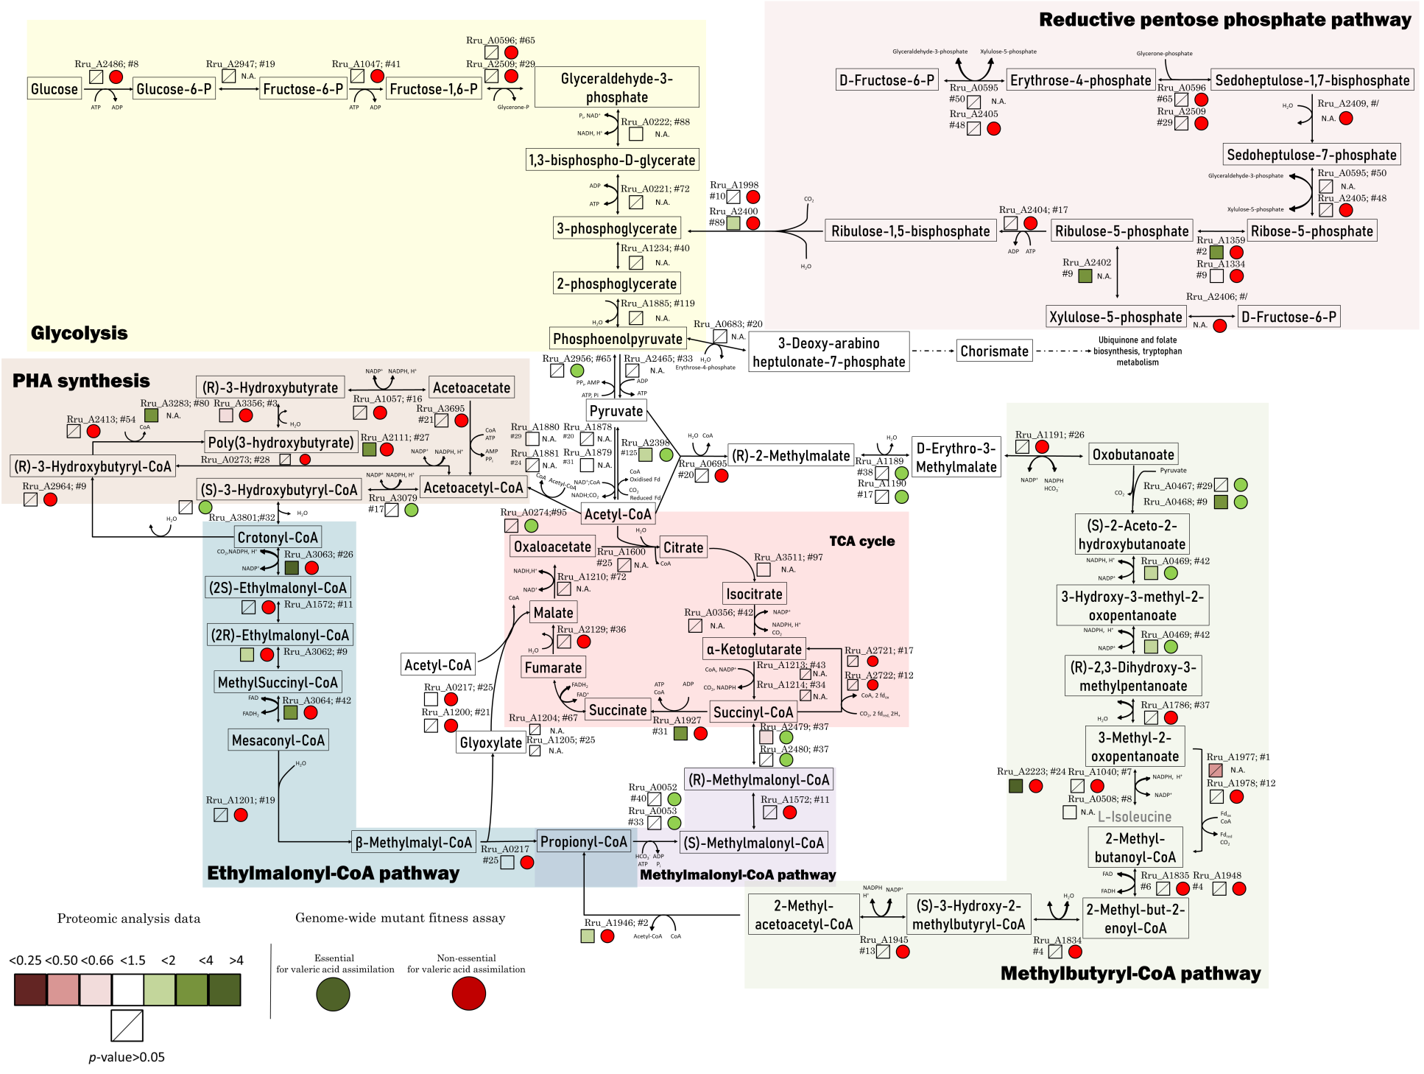

Figure 3
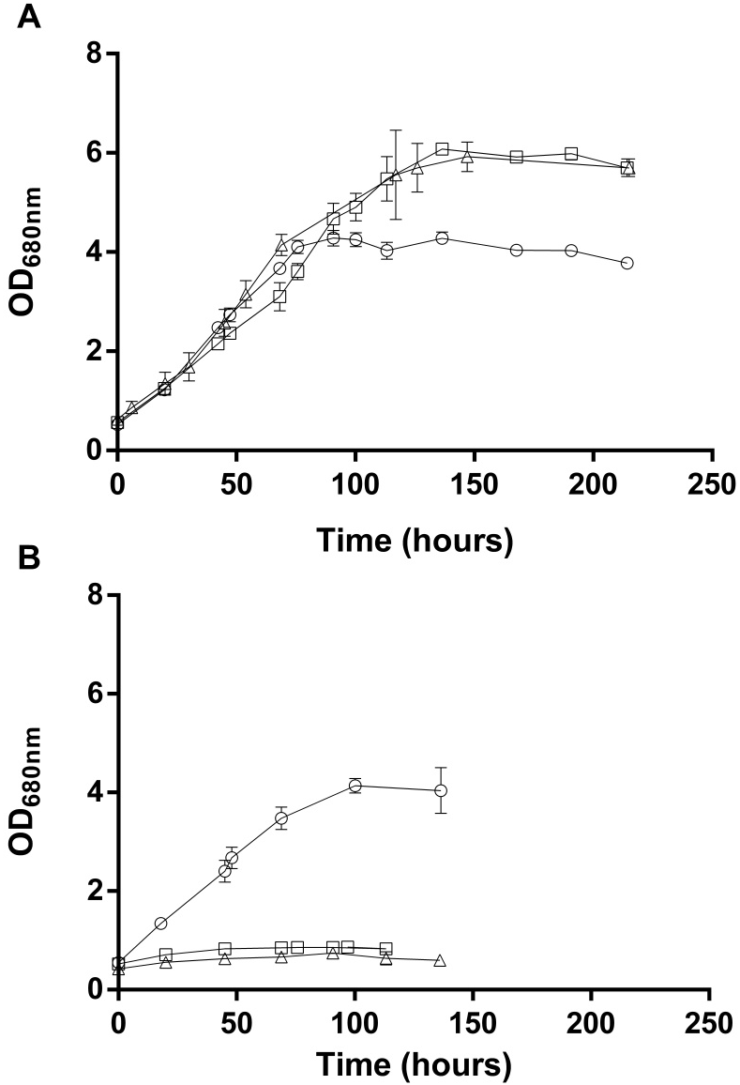

Figure 4
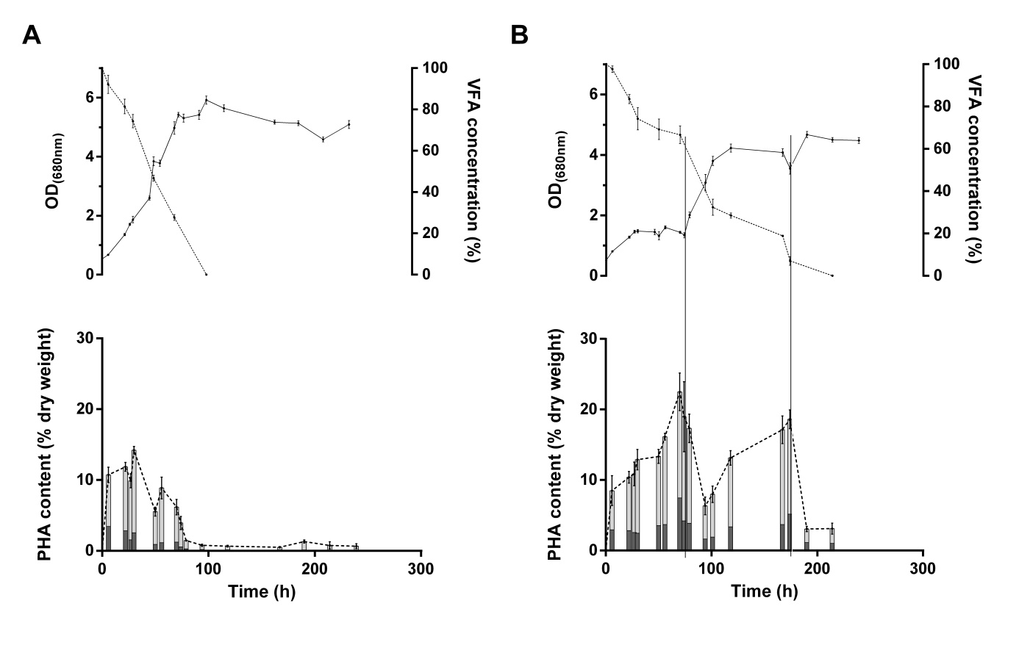

Figure 5
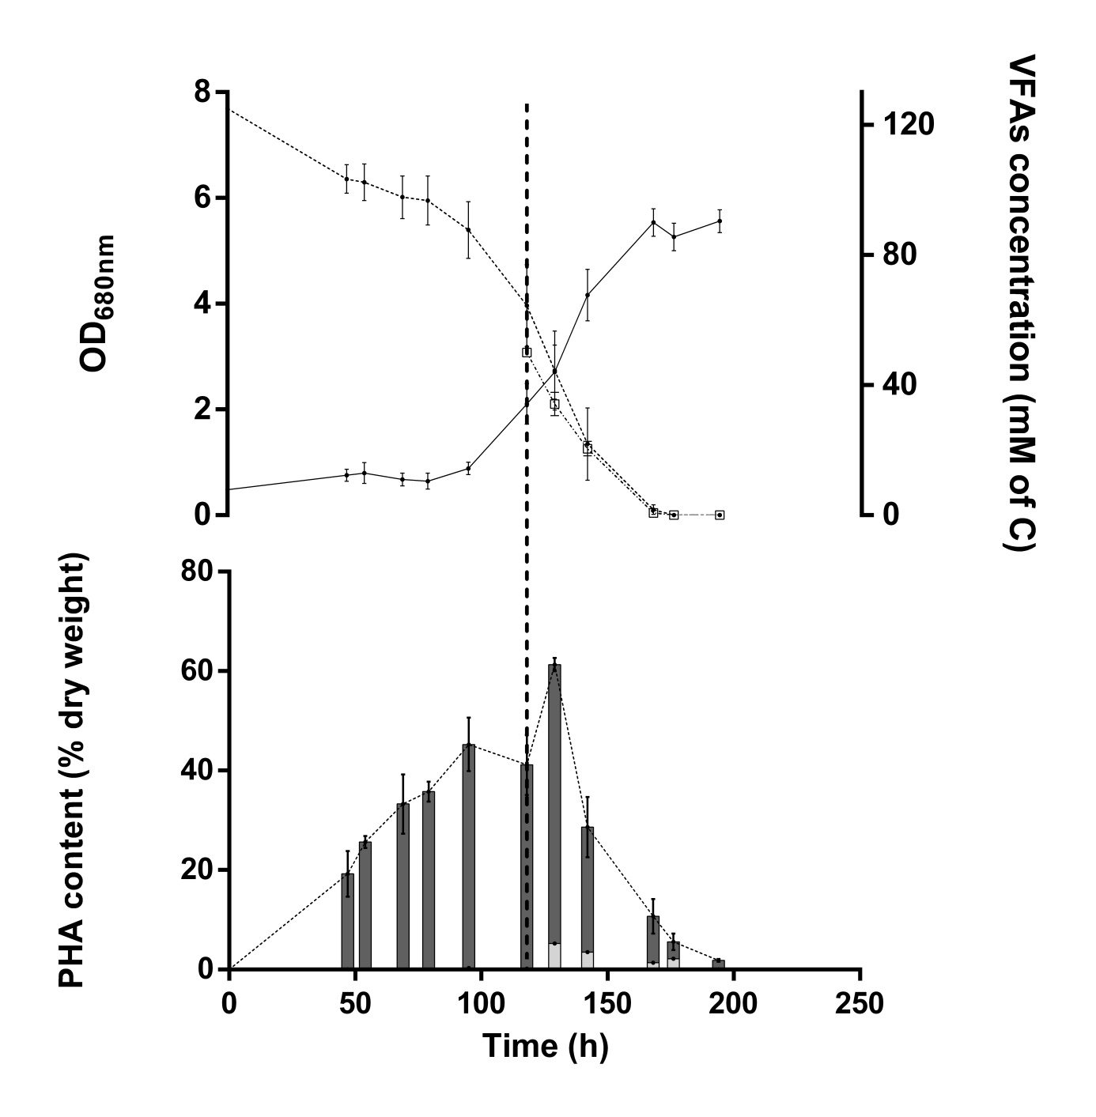

Table

Table 1:
Peak Name | Locus Tag | Description | Proteomic analysis |  |  | Mutant fitness assay
 |  |  | p-value | Fold change Val/Succ | #Identified peptides | Fitness value Succinate | Fitness value Valerate
Stress handling and redox homeostasis
Q2RW01 | Rru_A0893 | Stress protein | 7.17E-03 | 2.00 | 41 | N.A. | N.A.
Q2RW00 | Rru_A0894 | Stress protein | 3.87E-02 | 1.91 | 78 | -0.67 | -1.24
Q2RUH6 | Rru_A1418 | Alkyl hydroperoxide reductase/ Thiol specific antioxidant/ Mal allergen | 2.40E-03 | 1.60 | 42 | N.A. | N.A.
Q2RTI5 | Rru_A1760 | Superoxide dismutase | 5.30E-04 | 2.09 | 51 | N.A. | N.A.
Polyhydroxyalkanoate metabolism
Q2RXR6 | Rru_A0274 | Acetyl-CoA C-acetyltransferase | 0.51 | 0.95 | 95 | 0.5 | -2.4
Q2RSI4 | Rru_A2111 | Uncharacterised protein-potential phasin | 2.24E-06 | 3.56 | 27 | -0.44 | 0.37
Q2RQI1 | Rru_A2817 | Phasin | 3.80E-04 | 48.24 | 24 | -0.19 | 0.01
Q2RPS1 | Rru_A3079 | 3-hydroxyacyl-CoA dehydrogenase | 0.38 | 1.19 | 17 | -0.3 | -1.2
Q2RP67 | Rru_A3283 | Phasin | 2.79E-02 | 2.06 | 80 | N.A. | N.A.
Q2RNZ5 | Rru_A3356 | Polyhydroxyalkanoate depolymerase | 4.14E-03 | 0.58 | 3 | 0.02 | -0.28

Supplementary informations
Supplementary table 1 : Gene fitness values of genes involved in connecting route to Ethylmalonyl-CoA pathway in Rhodospirillum rubrum S1H
Locus name | Description | Gene fitness |  | Significance
 |  | Succinate | Valerate | Valerate vs Succinate
Connecting route Ethylmalonyl-CoA pathway
Rru_A0273 | 3-oxoacyl-[ACP] reductase | 0,4 | 0,2 | 1,28E-01
Rru_A0274 | Acetyl-CoA C-acetyltransferase | 0,5 | -2,4 | 8,62E-04
Rru_A3079 | 3-hydroxyacyl-CoA dehydrogenase | -0,3 | -1,2 | 7,67E-03
Rru_A3801 | Short chain enoyl-CoA hydratase | -0,2 | -0,9 | 2,62E-02
Rru_A2964 | (R )-enoyl-CoA hydratase | -0,2 | 0,7 | 1,42E-04

Supplementary table 2 : Gene fitness values of genes involved in Ethylmalonyl-CoA, methylmalonyl-CoA pathways and Krebs cycle in Rhodospirillum rubrum S1H
Locus name | Description | Gene fitness |  | Significance
 |  | Succinate | Valerate | Valerate vs Succinate
Ethylmalonyl-CoA + Methylmalonly-CoA and Krebs cycle
Rru_A3063 | Crotonyl-CoA reductase/carboxylase | -0,1 | -0,1 | 5,35E-01
Rru_A1572 | Methylmalonyl-CoA epimerase | -1,0 | -1,4 | 5,07E-01
Rru_A3062 | Methylmalonyl-CoA mutase | 0,0 | -0,1 | 2,24E-01
Rru_A3064 | Isovaleryl-CoA dehydrogenase | 0,0 | -0,1 | 1,62E-01
Rru_A1201 | malyl-CoA/β-methylmalyl-CoA lyase | 0,1 | -0,1 | 4,22E-03
Rru_A0217 | Citrate lyase | 0,0 | -0,1 | 2,97E-01
Rru_A1200 | Citrate lyase | -0,2 | 0,0 | 3,11E-02
Rru_A0052 | Biotin carboxylase | 0,1 | -2,6 | 2,22E-04
Rru_A0053 | Carboxyl transferase | 0,1 | -2,6 | 1,55E-04
Rru_A2479 | Methylmalonyl-CoA mutase | -0,3 | -0,9 | 2,81E-02
Rru_A2480 | Methylmalonyl-CoA mutase | -0,2 | -1,0 | 3,24E-02
Rru_A1927 | Acetyl-CoA hydrolase | 0,0 | 0,2 | 6,71E-03
Rru_A1203 | Succinate dehydrogenase subunit D | n.a. | n.a. | n.a.
Rru_A1204 | Succinate dehydrogenaseflavoprotein subunit | n.a. | n.a. | n.a.
Rru_A1205 | Succinate dehydrogenase iron-sulfur subunit | n.a. | n.a. | n.a.
Rru_A2129 | Fumarate hydratase class II | -0,1 | -0,1 | 7,14E-01
Rru_A2206 | Fumarate hydratase class I | n.a. | n.a. | n.a.

Supplementary table 3 : Gene fitness values of genes involved in isoleucine biosynthesis pathway in Rhodospirillum rubrum S1H
Locus name | Description | Gene fitness |  | Significance
 |  | Succinate | Valerate | Valerate vs Succinate
Isoleucine Biosynthesis pathway
Rru_A2398 | pyruvate-ferredoxin/flavodoxin oxidoreductase | 0,0 | -0,9 | 1,11E-03
Rru_A0695 | 2-isopropylmalate synthase | 0,2 | 0,1 | 6,04E-01
Rru_A1189 | 3-isopropylmalate/(R)-2-methylmalate dehydratase large subunit | -2,1 | -3,7 | 1,91E-02
Rru_A1190 | 3-isopropylmalate/(R)-2-methylmalate dehydratase small subunit | -1,9 | -3,8 | 1,86E-02
Rru_A1191 | 3-isopropylmalate dehydrogenase | -2,3 | -2,8 | 3,11E-01
Rru_A0467 | acetolactate synthase I/II/III large subunit | -1,2 | -2,8 | 2,20E-02
Rru_A0468 | acetolactate synthase I/III small subunit | -0,4 | -2,3 | 4,25E-02
Rru_A0469 | ketol-acid reductoisomerase | -2,2 | -2,9 | 3,15E-02
Rru_A1786 | dihydroxy-acid dehydratase | -2,5 | -3,1 | 8,29E-02
Rru_A1040 | leucine dehydrogenase | -0,1 | -0,3 | 2,21E-01
Rru_A0508 | branched-chain amino acid aminotransferase | 0,1 | 0,2 | 4,77E-01
Rru_A2223 | branched-chain amino acid aminotransferase | -0,3 | 0,0 | 3,02E-02

Supplementary table 4: Gene fitness values of genes involved in isoleucine degradation pathway in Rhodospirillum rubrum S1H
Locus name | Description | Gene fitness |  | Significance
 |  | Succinate | Valerate | Valerate vs Succinate
Isoleucine Degradation pathway
Rru_A1977 | indolepyruvate ferredoxin oxidoreductase, beta subunit | n.a. | n.a. | n.a.
Rru_A1978 | indolepyruvate ferredoxin oxidoreductase, alpha subunit | 0,1 | 0,1 | 9,26E-01
Rru_A1835 | butyryl-CoA dehydrogenase | -0,1 | 0,0 | 1,71E-01
Rru_A1948 | isovaleryl-CoA dehydrogenase | 0,0 | 0,0 | 2,15E-01
Rru_A1834 | enoyl-CoA hydratase | 0,1 | 0,0 | 3,09E-01
Rru_A1945 | short-chain dehydrogenase | -0,1 | -0,1 | 7,33E-01
Rru_A1946 | acetyl-CoA C-acetyltransferase | -0,2 | -0,1 | 2,74E-02

Supplementary Figure 1 : PCR attesting the mutation of the Δccr::km^{R} strain.

