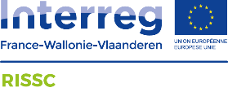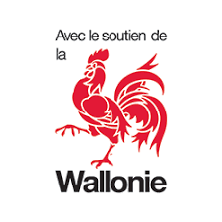
WITH THE SUPPORT OF THE EUROPEAN REGIONAL DEVELOPMENT FUND
RISSC: Towards a better management of cavity-related ground movements in Wallonia and Hauts-de-France Regions
Lorraine DEWAIDE¹, Fanny DESCAMPS², Cédric LEFEBVRE³, Catherine PINON⁴ & Jean-Marc WATELET⁵
1. ISSeP, Colfontaine, Belgium (l.dewaide@issep.be)
2. UMONS, Mons, Belgium (fanny.descamps@umons.ac.be)
3. CEREMA, Sequedin, France (cedric.lefebvre@cerema.fr)
4. Ineris, Verneuil-en-Halatte, France (catherine.pinon@ineris.fr)
5. Ineris, Verneuil-en-Halatte, France (jean-marc.watelet@ineris.fr)

The RISSC project (https://www.rissc-interreg.eu/) is supported by the European “Interreg” program which develops social and economic cooperation between European regions. In this framework, Wallonia and Hauts-de-France Regions cooperate to improve risk management related to ground movements due to underground cavities. Due to similar geologic context and industrial history, both territories host similar cavities (natural or anthropic). These cavities induce a potential threat for the population or the infrastructures in terms of ground stability. However, the risk management is different in the two border regions because of distinct national or regional politic strategies. Furthermore, the tools that are used on both sides of the border need to be upgraded. For these reasons, the RISSC project has emerged in order to provide common and better tools for the prevention and the management of cavity-related ground movement issues.
Thanks to the cooperative work of several cross-border experts, RISSC achieves concrete results through three main work actions:
- Inventory of the cavities and the threats, and characterization of the possible consequences at the surface;
- Development of local solutions to monitor or even reduce the risk;
- Supply of technical assistance for local actors and population through the creation of useful tools and sources of information.

Inventory and characterization

Inventories of underground cavities have been established on both sides of the border. Cross-check of these information allows to propose common typology and description of the cavity types. The possible threats they represent need to be assessed, namely through physical data. Several test sites were chosen and works have been conducted on site and in laboratory by actors of the RISSC project. Investigations lead to effective characterization of rock masses. Figure 1 illustrates a geo-mechanical map established on the site of La Malogne quarry (Wallonia). This analysis feeds the numerical models that are developed to assess the stability of cavities.
This work axis also aims to compare and improve existing methodologies for the evaluation of ground movement hazard (Kheffi and Pacyna, 2018; Ineris, 2012). The methods are applied on different sites across the border where ground movements represent a risk., and hazard mapping are built. Furthermore, compared accidents (collapse) analysis on both territories can be carried out in order to understand the mechanisms and the context that favour collapsing events. This approach is very important for the improvement of risk management politics.

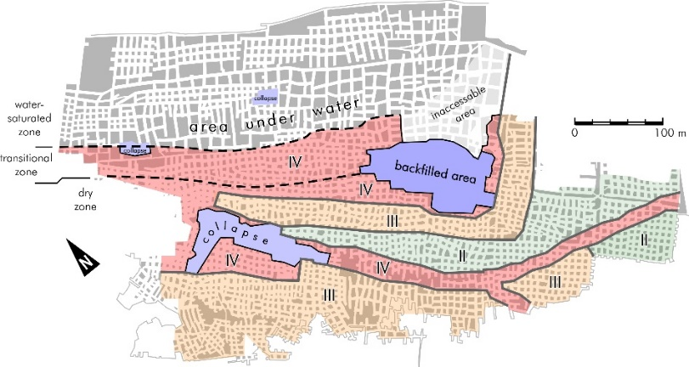
Figure 1. Definition of geo-mechanical zones on the test-site of La Malogne, ancient quarry (Belgium): II - Good rock mass quality; III – Fair rock mass quality, IV – Poor rock mass quality; and collapsed areas (Georgevia et al., 2020).

Local solutions for monitoring and reducing the risk

In this part of the project, the different techniques used for risk management (monitoring and securing) are addressed. Some of them are tested on pilot sites. This axis of the research aims to provide suitable solutions for specific contexts in terms of geology, type of cavity (shape and size), etc. Alternative solutions, as touristic valorisation, are also explored.

Technical support

This part of the project has, as main objective, to create an effective cross-border interaction between public services, local authorities and actors, experts and population. Through the lessons learned from the various technical works driven by the RISSC project, useful tools ought to be created (geo-portal, methodology guides, practical information, …). Those tools will support the work of all the actors implied in the cavity risk management who should be included in a cross-border network created on the initiative of the RISSC project.
Acknowledgements
The authors thank the European Regional Development Fund (ERDF), through the Interreg V FWVl program, and Wallonia for funding the research.

References

Georgieva, T., Descamps, F., Vandycke, S., Ajdanlijsky, G., Tshibangu, JP. (2020). Caractérisation géomécanique d’une carrière souterraine abandonnée par des méthodes in-situ. Journées Nationales de Géotechnique et Géologie de l’Ingénieur, Lyon, 2020.

Kheffi A., Pacyna D. (2018). Elaboration de cartographies de zones d’aléas de mouvement de terrain engendrés par les objets souterrains connus de Wallonie – Rapport méthodologique, Département de l'Environnement et de l'Eau (DGO3), 0326/2018.

Ineris, DGPR (Ministère de l’Ecologie, du Développement durable et de l’Energie), 2012.
Plan de Prévention des Risques Naturels. Guide méthodologique : cavités souterraines abandonnées.

