Type of Presentation:  Oral | Topic:  Gas sensors
Role of cobalt in Co-ZnO nanoflower gas sensors for the detection of low concentration VOCs

Y. Luo ¹, A. Ly ², D. Lahem ², C. Zhang ³ and M. Debliquy ²
¹Service de Science des Matériaux, Faculté Polytechnique, University of Mons, Mons 7000, Belgium
² Material Science Department, Materia Nova ASBL, Mons 7000, Belgium
³ College of Mechanical Engineering, Yangzhou University, Yangzhou 225127, P.R. China

Tel.: +32 465614284, fax: + 87654321
E-mail: Yifan.LUO@umons.ac.be

Abstract: As a non-invasive detection method, breath analysis for the diagnosis of lung cancer has been a hotspot in the medical field. Using an e-nose to achieve the breath analysis is a popular choice. To prepare the sensors used in the e-nose for the detection of the volatile organic compounds which are considered as the biomarkers for lung cancers, cobalt doped ZnO sensors with high response to low concentration VOCs were fabricated. The Co-ZnO samples were synthesized via wet chemical method and drop coated onto the alumina substrates equipped with gold interdigitated electrodes after calcination. The as-synthesized materials were characterized by SEM, XRD, FT-IR and XPS to observe the microstructure, the crystal phase and the states of Co atom in the samples. The sensors were tested with various VOCs at different temperatures. showing a strong influence of the different amounts of Co²⁺ addition on the sensing characteristics. The difference in the sensing performance could be explained by the different phases of Co in the sensing layers.

Keywords: ZnO; Co doping; p-n heterojunctions; gas sensor; VOCs; lung cancer

1. Introduction
In the medical field, developing non-invasive diagnosis methods for lung cancer has become a hotspot. Among them, breath analysis is an efficient method tracking gases, volatile organic compounds (VOCs), considered as biomarkers.[1-3] Traditionally, gas chromatography was used to study the components in breath analysis but the size and cost of the equipment and difficulties in data analysis made it hard to be used for doctors. Therefore e-nose can be good choice. Biomarkers in breath are at low concentrations, mostly in the ppb range and it becomes essential to develop sensors with high response to those biomarkers. Here we focused on isopropanol which seems to be an important biomarker for lung cancer. [4-5] Semiconductor gas sensors can be candidates due to their relative high response and low cost. Howver, pure metal oxide such as ZnO cannot fit the requirement of detecting ppb level concentration change of VOCs, so it is necessary to modify the metal oxide. Synthesizing nanostrucutres with high specific surface area, doping or building p-n heterojuhnctions between two different semiconductors are efficient methods to improve the response of semiconductor sensors. [6-8] The operating mechanism of metal oxide semiconductor is the In this work, we synthesized cobalt assisted flower like zinc oxide (Co-ZnO) as sensing material. The ratio between Co and ZnO were adjusted and its influence on the sensing performances was studied.
2. Experiments
The Co-ZnO composites were synthesized via a chemical deposition method. First, x mmol Co(NO₃)₂•6H₂O and 3-x mmol Zn(NO₃)₂•6H₂O were dissolved in 55 ml of deionized (DI) water, which was marked as solution A. x was set as 0.3, 0.6, 0.9, 1.2 and 1.5 (10 at%, 20 at%, 30 at%, 30 at% and 50 at% Co respectively). The obtained samples are named as 10Co, 20Co 30Co 40Co and 50Co respectively. At the same time, 30 mmol of 2-Methylimidazole (MeIM) was dissolved in 50 mmol of DI water and magnetically stirred until the solution becomes clear. The solution was marked as solution B. Solution B was poured into solution A, then 15.5 ml of ammonia was immediately added into the solution. Afterwards, the purple solution was magnetically stirred at room temperature for 2 h. The purple precipitates were centrifugated and washed and dried at 80ºC overnight. To prepare the Co-ZnO, the as-prepared purple powders were calcinated at 500ºC for 2 h. For making the sensors, the as-prepared powders were drop coated on an alumina substrate with interdigitated gold electrodes. The gas sensing test was carried out in a homemade testing system. The testing system and the testing method are the same as introduced in ref. [9] The response of n-type and p-type sensors is defined as:
$S={(R}_{a}-R_{g})/R_{g}$ or $S={(R}_{g}-R_{a})/R_{a}$ (1)
S is the sensor response, R_{g} is the resistance of the sensor in target gas and R_{a} is the resistance of the sensor in synthetic air. The response and recovery times were defined as the time needed to reach 90% of the maximum response and to recover to 110% of the baseline.
3. Results
To study the role of Co in the sensor, we performed several characterizations to the material. The scanning electron microscope (SEM) picture showed that all of the samples have similar morphology, which is a nanosheet assembled flower-like structure with pores of about 36 nm, as is shown in Fig. 1. X-ray diffraction (XRD) proved that after the calcination, in the 10Co and 20Co samples, only ZnO exist, while in the other groups, there are both ZnO and Co₃O₄. In X-ray photoelectron spectroscopy (XPS), the O 1s region, a new peak at 529.5 eV can be found in 30Co, 40Co and 50Co. This peak is related to the Co³⁺ in Co₃O₄, which is consistent with the result of XRD. In the Co 2p region, in 10Co and 20Co, the state of Co can be considered as Co²⁺, the 30Co is a mixture of Co²⁺ and Co³⁺. In 40Co and 50Co, the Co is mostly Co³⁺. According to reference [10], when the atom ratio of Co is less than 30 at%, the form of the sample is more likely to be a Co substituted ZnO; when the content of Co is more than 30 at%, the samples are a ZnO-Co₃O₄.
For the gas sensing performance, the results are shown in Fig. 2. Fig. 2(a) shows the relationship between sensor responses and operating temperature. The 10Co and 20Co reached the highest response at 225ºC, while the others had the best response at 250ºC. Fig. 2(b) shows the dynamic response of the Co-ZnO sensors to 5 ppm isopropanol. The electrical resistance decreased with the increase of Co addition, especially when it is more than 30 at%. Also, when Co is more than 40%, the resistance in gas increases, which means there is a n-p type reverse. According to Fig. 2(c), the 10Co sensor showed the best response to 5 ppm isopropanol at 225ºC, the response time and recovery time was 330 s and 475.16 s. In Fig. 2(d), the response of the 30Co to 5 ppm of acetone becomes high. It is much higher than the value at 250ºC. For the repeatability, we tested the sensors with isopropanol at the best working temperature, in 10 days’ test, the variation of the response is less than 10%, which can be considered as a stable sensor.
For the sensing mechanism, first, when the sensors are exposed to air the oxygen molecules adsorb on the surface of the sensing layer, generating O⁻ ions. In this step, the oxygen molecules capture the free electrons in the sensing layer and lead to the increase of the resistance of the sensing layer. Once the isopropanol is injected into the testing chamber, the gas reacts with the adsorbed oxygen ionsreleasing the electrons into the sensing layer, which caused the change of the resistance. The doping withCo changes the bandgap structure of the ZnO which is the main influence in 10Co and 20Co, while the p-n heterojunctions between Co₃O₄ and ZnO plays the major role in the other groups.
4. Conclusion
In this work, two kinds of the nanosheet-assembled flower of Co-ZnO sensors have been successfully synthesized through the same chemical deposition method The Co substituted ZnO showed good response to isopropanol while the one with Co₃O₄ was more sensitive to acetone. The improvement of the sensing performance can be summarized as the increase of the specific surface area, the doping effect of Co²⁺ and the construction of p-n heterojunctions between Co₃O₄ and ZnO.
Acknowledgements
The authors would like to thank the European Regional Development Fund (ERDF) and the Walloon Region of Belgium who financially supported this work through the Interreg V France-Wallonie-Vlaanderen program, under PATHACOV project and the Micro+ project co-funded by the European Regional Development Fund (ERDF) and Wallonia, Belgium (No. 675781- 642409). This work was also supported by the Communauté Wallonie-Bruxelles via the WBI-MOST-China (SUB/2019/430254) grant.
References
[1] M. P. van der Schee, R. Palmay, J. O. Cowan and D. R. Taylor. Predicting steroid responsiveness in patients with asthma using exhaled breath profiling. Clinical & Experimental Allergy, Vol.0 43, Issue 11, 2013, pp. 1217-1225.
[2] C. Di Natale, R. Paolesse, E. Martinelli and R. Capuano. Solid-state gas sensors for breath analysis: A review. Analytica Chimica Acta, Vol. 824, 2014, pp. 1-17.
[3] P. Fuchs, C. Loeseken, J. K. Schubert and W. Miekisch. Breath gas aldehydes as biomarkers of lung cancer. International Journal of Cancer, Vol. 126, Issue 11, 2010, pp. 2663-2670.
[4] Y. Saalberg and M. Wolff. VOC breath biomarkers in lung cancer. Clinica Chimica Acta, Vol. 459, 2016, pp. 5-9.
[5] G. Song, T. Qin, H. Liu, et al. Quantitative breath analysis of volatile organic compounds of lung cancer patients. Lung Cancer, Vol. 67, Issue 2, 2010, pp. 227-231.
[6] Meng, F., N. Hou, S. Ge, et al. Flower-like hierarchical structures consisting of porous single-crystalline ZnO nanosheets and their gas sensing properties to volatile organic compounds (VOCs). Journal of Alloys and Compounds, Vol. 626, 2015, pp. 124-130.
[7] R. Yoo, A. Güntner, Y. Park, H. Rim. H. Lee and W.Lee. Sensing of acetone by Al-doped ZnO. Sensors and Actuators B: Chemical, Vol. 283, 2019, pp. 107-115
[8] J. Huang, Y. Dai, C. Gu, Y. Sun and J. Liu. Preparation of porous flower-like CuO/ZnO nanostructures and analysis of their gas-sensing property. Journal of Alloys and Compounds, Vol. 575, 2013, pp. 115-122,
[9] Y. Luo, A. Ly, D. Lahem, C. Zhang and M. Debliquy. A novel low-concentration isopropanol gas sensor based on Fe-doped ZnO nanoneedles and its gas sensing mechanism. Journal of Materials Science, Vol 54, Issue 4, 2021, pp. 3230-3245.
[10] F. Rong, J. Zhao, P. Su, Y. Yao, M. Li, Q. Yang, C. Li. Zinc–cobalt oxides as efficient water oxidation catalysts: the promotion effect of ZnO. Journal of Materials Chemistry A, Vol. 3, Issue 7, 2015, pp. 4010-4017.
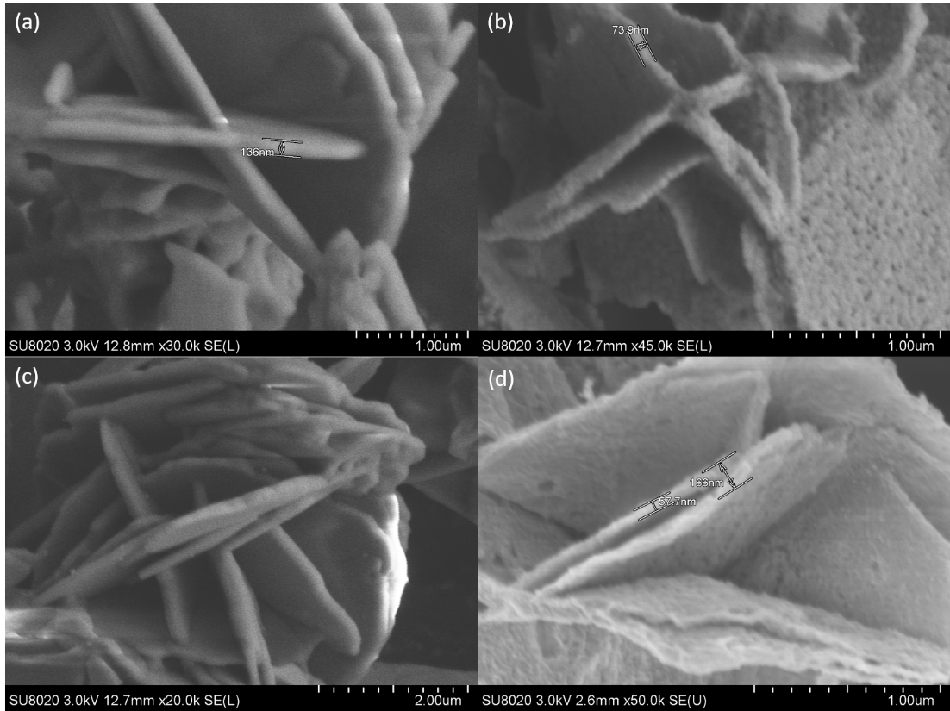
Fig. 1 SEM images of (a) 10Co before calcination (b) 10Co after calcination (c) 40Co before calcination (d) 40Co after calcination
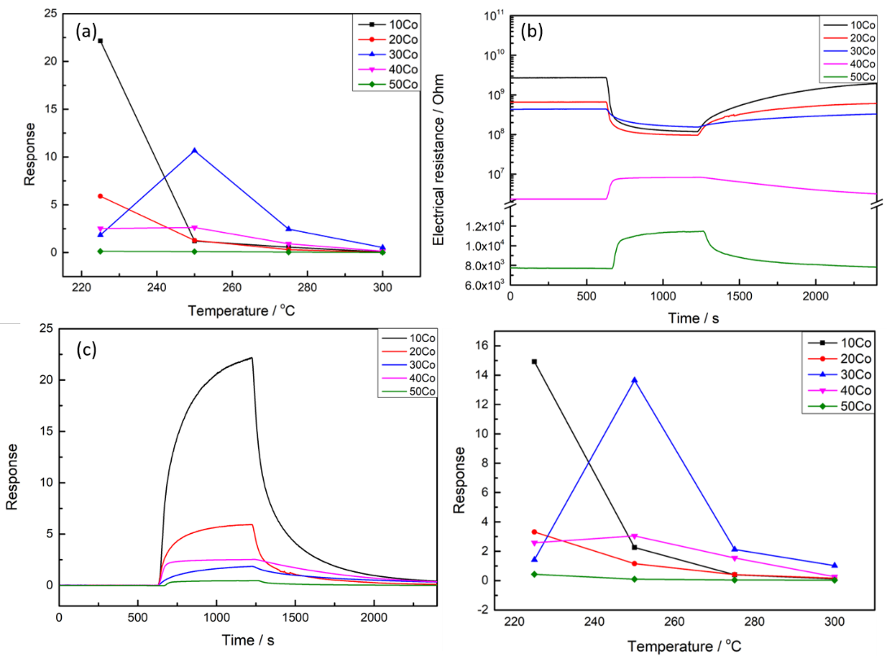
Fig. 2 (a) Responses of Co-ZnO sensors to 5 ppm isopropanol at different working temperatures; (b) Electrical resistance changes of Co-ZnO sensors with 5 ppm isopropanol at 225ºC; (c) Dynamic responses of the Co-ZnO sensors to 5 ppm of isopropanol at 225ºC; (d) Response of Co-ZnO sensors to 5 ppm of acetone at different working temperature

